INTEGRATING CONFLICT SENSITIVITY IN NEEDS ASSESSMENTS

Conflict analysis is the first step in applying conflict sensitivity. While a full conflict analysis is necessary in certain context, resources and time are not always sufficient to do so. Doing a ‘light’ analysis is a first step to ensure your project is conflict sensitive enough.

This is a guidance on how to do a ‘light’ analysis by integrating conflicts sensitivity in a larger needs assessments, using both desk review, interviews and more participatory methods.

You will find guidance on:
- Key principles.
- Methodology:
  - Key points to analyze.
  - Who should be consulted, and how.
  - Questions to put in your needs assessment so it integrates conflict sensitivity.
- Annexes with guidance on the different tools you can use.

KEY PRINCIPLES

Objectives: to better understand the implementation context of your project and how your project will interact with existing tensions, you need to identify and understand:
- Relevant groups/actors of the tensions, their positions and underlying interests/needs/fears, and their relations (incl. direct conflict actors, implementing partners, yourself).
- Conflict drivers and drivers of peace.
- Conflict dynamics, different possible developments/trends/changes.

Draw on existing knowledge and materials: there is probably a lot of analysis on the conflicts in your zone of intervention that can be used => Start by undertaking a desk review (see annex I for resources on conflicts).

Get information/analysis from a variety of actors, through interviews, focus group discussions with communities and a short analysis workshop with your staff/partners.
This is a key point to ensure a proper analysis: your sources should be diverse to avoid any bias and ensure it takes into account the voices of minorities. In particular, pay attention to:
- Include women and have a gender-sensitive analysis.
- Fairness in the representation of the different groups that are part of the conflicts.
- Take into account that your staff or partners might over-represent certain categories/communities, and balance this.

See the section on who should be consulted for more details.

Ensure the time and effort on analysis is proportionate to the size and risk level of the project. It’s ok to do a light and very localized analysis for an area with low tensions. An area where tensions are high and linked to a more global/national conflict requires a deeper analysis.

If you lack resources or time, it can be done “lightly” and then be deepened at a later stage (when the proposal is validated). In this case, use the “good enough” checklist to verify that the basis of conflict sensitivity has been integrated.

Be aware that the conflict context analysis is already an action that can do harm, and ensure you are doing it in a conflict sensitive way.

METHODOLOGY

In summary, the key steps to follow

- Start by deciding the person or team in charge (it could be the person leading the needs assessment, or someone that will support it).
- Lay out the framework of your analysis (your resources, why you are doing it, what do you need to study). It’s time to define the objectives, the level of analysis, and the steps to follow, as described in the sections below.
- Start with a desk review, to establish which information and level of analysis is already accessible (internal and external) to address the key conflict analysis questions. At this moment, also list the risks of bias and under-representation. On this basis, you can start the analysis, and identify gaps that you will have to address during the next steps.
- Organize a workshop with key staff (and local partners if relevant) to conduct a session of discussion and collective analysis (using tools shared in annexes).
- Once you have established what types of information/analysis you need and lack, and validated the adequate approach in your internal workshop, plan exchanges with analysts and communities.

What do you need to analyze/review?

At the end of the assessment, you need to be able to respond to the following points:

- Define the challenges: what are the tensions and conflicts in the area?
- Identify actors and their relations, for instance through actor mapping (see tools in annex II).
- Identify dividers (things that increase tension, divisions or capacities for conflict between groups of people; that increase suspicion, mistrust or inequality in a society) and connectors (things that bring people together despite their differences, and decrease suspicion, mistrust and inequality in a society).
- Identify the response of authorities and key governance problems.
- Scenario building: identify the different possible scenario of evolutions of the tensions.

Who should be consulted, and how?

- Diversity and inclusion: a key point to start your planning
To have a clear understanding of the tensions and the risks, you need to hear all voices. However, in a lot of contexts, inequalities and segregation create situations where certain groups are over-represented or underrepresented. If you do not actively seek to balance those inequalities, it is very likely that your analysis will be biased or incomplete.
For instance:
- Staff and local community leaders might be mostly male. If you do not seek to specifically hear the voice of women, your analysis will not be gender sensitive.
- Staff might mainly come from the same community or social class. Despite their efforts to be impartial, it’s key to ensure voices of other communities are given enough space and influence.
What should be done:
- Start mapping out the different bias that could hamper your analysis (gender, ethnicity, social class …).
- If you identify groups that will be under-represented, put in place a way to ensure their voice will be heard. Representativeness should be ensured in the panel of interlocutors you speak to, but also regarding the staff that works on the assessment. Diversity in the staff leading the assessment is a way to reduce the risk of bias or forgotten voices.

- The types of interlocutors and exchanges you can plan

Internally
Plan an internal workshop (with local partners if relevant). This internal workshop will serve two objectives: to discuss and finalize the design of your conflict sensitive needs assessment, and to start the conflict analysis.
How to organize the workshop:
- Refresher about do no harm and conflict sensitivity
Depending on the knowledge of the staff, take some time to remind everyone about the principles.
- Presentation of the objectives/strategy/approaches that you have define for your assessment
This is key to challenge any bias or risks you approach might present, and to potentially improve it by benefiting from the analysis of your colleagues. It’s a good moment to check if your list of planned interlocutors is diverse enough.
- Conflict analysis session
Start the analysis per se by benefiting from the professional and personal experience of your colleagues, who might have a direct experience of the tensions or already studied them. This collective analysis can be facilitated by using the tools described in annex.
For instance:
- If you want to study the actors and reasons for the tensions, gather several small groups to work on the actor mapping and the onion. After that, each small group can present their findings and open the floor for discussion.
- If you want to understand better what and who can influence the conflict, small groups can work on the Lederach pyramid and the force field analysis.

The list of participants depends on the program, but be sure to be define it based on the gaps and bias you might have identified in step 1.

Externally
The type, number and length of your exchanges will of course depend on the resources and time you have.
Plan to exchange with two different “types of interlocutors”, for two different objectives.
- “Analysts”: people who can provide you with an “external” analysis of the conflict, its actors and evolutions. Depending on your knowledge of the zone and if you have sufficient recent context analysis documents, those interlocutors can help you get the big picture about the conflict and who is who.
  - Researchers, journalists, context analysts from other NGOs, mediation NGOs, diplomats …
  - If you already know well the zone and context, this step can be optional.
- “Communities”: the public concerned by your project, who can provide you with their analysis of the situation and indirect information to help you form an understanding of the situation. It’s best to mix two modalities:
  - Direct discussion with communities, through focus group discussions for instance.
  - Discussions with community leaders and representatives: interview with authorities, traditional representatives, CSO leaders…

Note that the two categories can overlap, and that no analysis is really impartial! Meeting with “analysts” is interesting because they can provide you with documented analysis of the conflict, and direct answers to your conflict analysis questions. However, their responses will often be biased and are unlikely to represent the views of the concerned. Thus, it’s essential to exchange with communities, get their vision of the situation, and form your own answers to the conflict sensitivity questions listed below. Similarly, community leaders will not always represent the whole community (they can be part of a specific community or class, mostly male etc.). Beware of who is marginalized, and thus who you should seek to directly talk to!

- Be Careful to not fuel tensions
Doing an assessment is already an action and can influence the context: your questions and interviews can impact tensions and “conflict lines”, especially if you are going to fight bias and underrepresentation of marginalized groups.
Consider the do no harm aspects when thinking how you will reach those marginalized groups, what questions you will ask and how will you handle sensitive information.

Questions that can guide a programme level conflict analysis

Below is a list of key questions that you can integrate in the needs assessment. To help with those questions, a list of key tools that can be used is shared in annex II. Note that not all questions will make sense for your context, use what is the most relevant.

Identify the key elements of the implementation area for analysis of the context:
- What is the area (geographic or conceptual) relevant to your organization’s work?
- At what level will the intervention be implemented? (i.e., local, national, etc.)

Identify actors in the context:
- What groups (ethnic, political, social, etc.) exist within the program implementation area?
- Can the implementation area be defined as “belonging to” or “territory of” any particular group or groups?
- What other interventions are taking place that will have an impact on the context?
- What is the government doing?
- What are NGOs doing?
- What local efforts are taking place?

Identify intergroup conflicts that have caused violence or are dangerous and may escalate into violence.
- Have any conflicts between identified groups erupted into violence?
- Are there non-violent conflicts that are significantly destructive, and/or have the potential to erupt into violence?
- Here it’s important to track tensions that could erupt in violence/severe conflict!

Understanding causes/ drivers of conflict and peace
- What are the characteristics of conflict and violence in the area where the programme will be implemented? (e.g. localised, national level, criminal, armed, non-armed, linked to extremism etc.)
- What are the key long-term factors that are driving conflict and violence in the area? (e.g. social, economic, political and security).
- What is supporting stability or prospects for peace?
- Are there factors driving conflict or supporting stability that relate directly to the sector or focus of the intervention? (e.g. security sector, education etc.)
- Are there linkages between national/regional level conflict drivers and local level conflict/ tensions in the area of intervention?
- Which combination of factors are the most significant in terms of driving conflict or increasing the risk of conflict? Or alternatively in promoting stability or prospects for peace?
- How does the conflict affect (or is influenced by) women/ girls differently to men/ boys?

Understanding the key actors
- Who are the actors (and institutions) who influence conflict and violence or prospects for peace in the area or sector of the intervention?
- What are their interests and incentives towards violence and/ or peace?
- What power do they hold and what is their impact?
- How do actors in the area of intervention relate to other local, national, regional, or international level actors that influence conflict?
- What role to women/ girls play as opposed to men/ boys?

Understanding the dynamics and trends of conflict and peace
- What are the current trends in conflict? Is it intensifying, decreasing or a stalemate?
- What are the likely triggers, or combination of factors and actors that might lead to an increase in conflict or violence?
- How do they relate to the sector or geographic area of intervention?
- Are there any windows of opportunity for peacebuilding that relate to the sector or area of intervention?
- What are the likely future scenarios in the conflict context?

Dividers and connectors:
- Which formal or informal governing policies, institutions or local, economic, technological, or cultural systems keep people apart or increase tensions between groups?
- Which institutions or systems help people overcome their differences or promote coexistence?
- What kinds of attitudes, stereotypes, threats or acts of violence exist in the context?
- How do people express tolerance, acceptance or appreciation for other groups?
- What are the specific values that may differ between groups and lead to tensions?
- What are the specific values that are shared among groups?
- Do groups share interests? Do they work together? Do groups have different interests in relation to shared resources?
- Have groups experienced a past or historical event differently?
- What experiences have groups shared in the past?
- Are there symbols, events, holidays or occasions that celebrate one group over the other? From which certain groups are excluded?
- Are there universal symbols of togetherness or peace recognized and celebrated by all groups?

ANNEXES

Annex I – Resources

General resources for conflict analysis information:
- International Crisis Group
- United States Institute for Peace
- Chatham House
- International Alert
- Saferworld
- Conciliation Resources
- Reliefweb
- Acled
- Human Right Watch
- Amnesty International
Many country specific resources exist and can be a great source of more direct information.

Annex II – Conflict Analysis Tools
This is a basic guidance, in case of questions you can reach out to CARE France.
The main tools you can use:
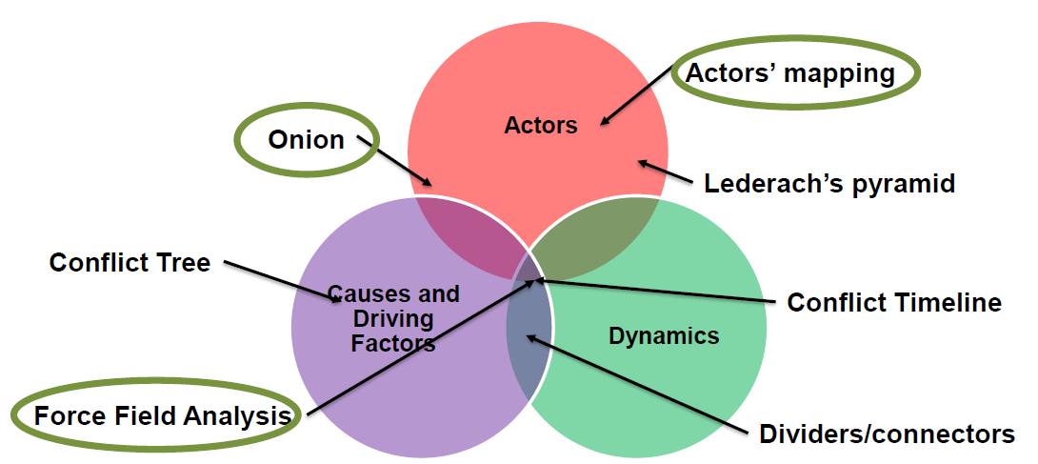

Note that the main objective of those tools is to help you develop and clarify your thoughts. It’s not necessary to use all the tools: it really depends on what areas of analysis you want to develop and what gaps there is in the analysis you already have. For instance, you might find a lot of external resources on the dynamics and history of the conflict but lack deeper understanding of the motivations of local actors in those tensions. In this case, the onion and actor mapping would be the tools to use.

- Summarize conflicts to watch for

Relevant tensions/conflicts | Intensity (mow, medium, high) | Probability of escalation (low, medium, high)

- Actor analysis
  - Actor mapping
To help you understand the context, links between actors and where/how your organization stands in this context.
- Ask: Who are the actors that are relevant to the conflict/crisis/tension?
- Write the names of the actors on round cards: smaller round cards for
- less powerful actors and bigger round cards for more powerful actors.
- What other parties are involved or connected to these actors? Include marginalised groups and external actors.
- Don’t forget to put your own organisation on the map.
- Connect the different cards by using various lines showing the quality of the relationship between them. Examples for different lines are given below.
- Reflect on the positions of different parties and try to identify alliances, close contacts, broken relationships and known confrontations. Identify what connects and divides them.

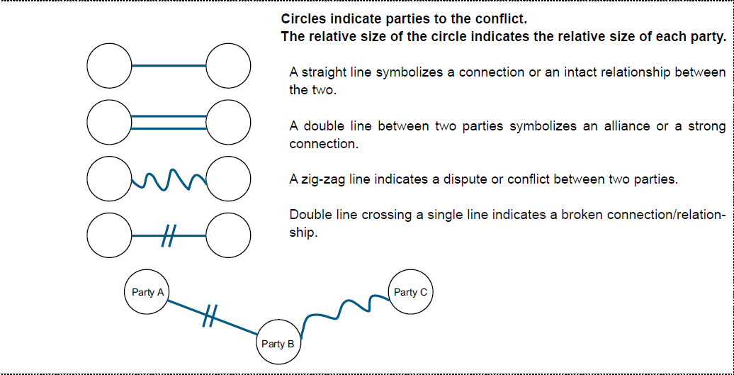

  - Onion
Focus on an actor to develop understanding of who it is and what he wants. It’s helpful in order to better understand reasons for tensions and potential triggers.

- Tools to analyze conflict dynamics
To understand the evolutions of tensions and how they might evolve in the future.
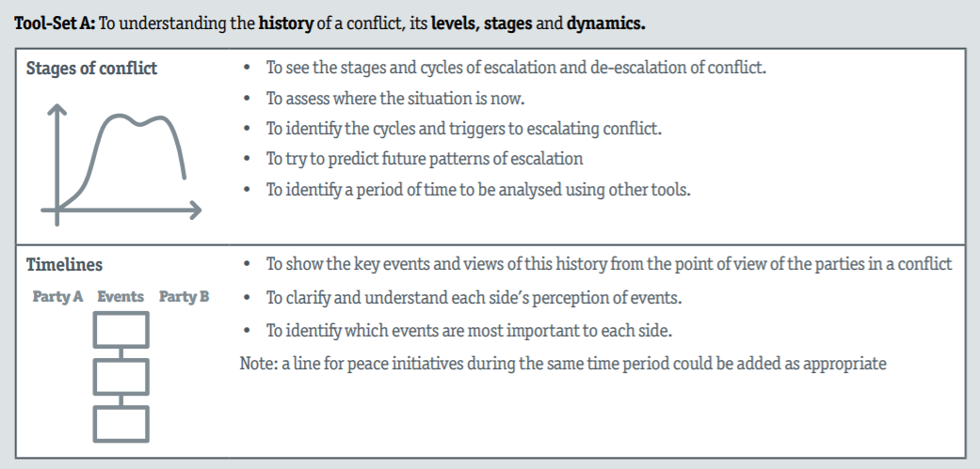

- Types of conflicts

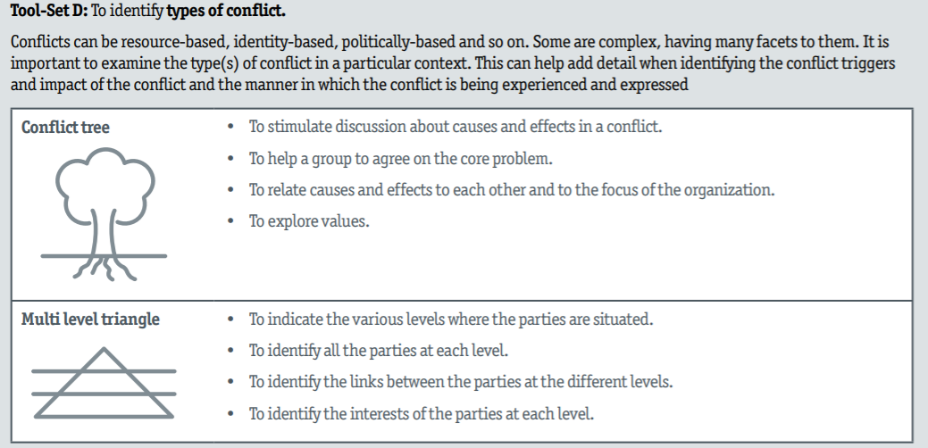

- Analyze power and influence relations

  - Lederach Pyramid:
Understand the power relationships and who can play a negative or positive influence on tensions.

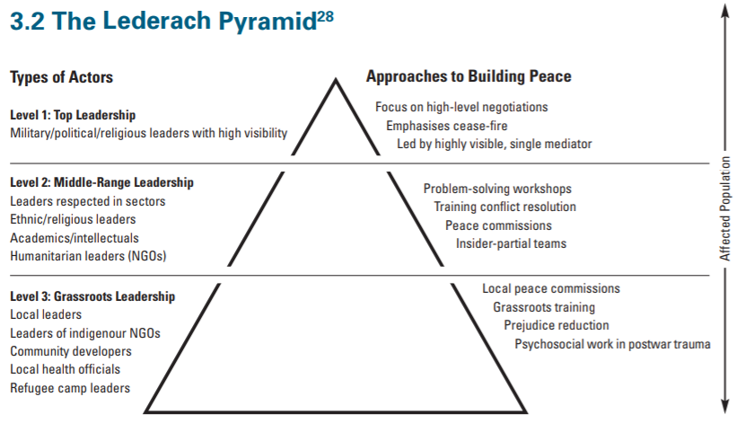
  - Force field analysis
Identify the factors that positively or negatively influence tensions. And see how these factors can be influenced.

