Roadmap for programme monitoring

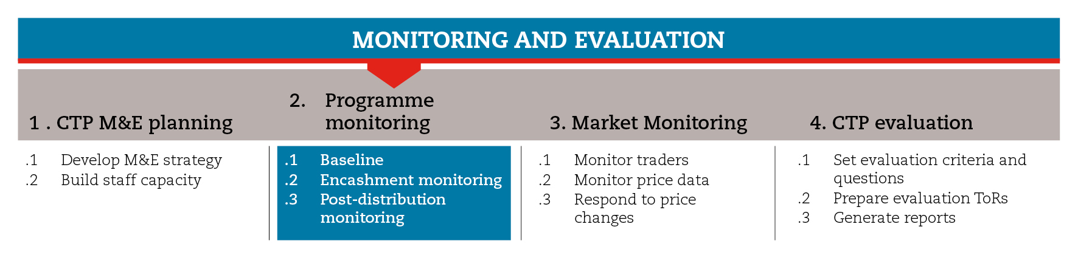

INTRODUCTION
This roadmap will guide you through the different elements of programme monitoring, including baseline, encashment and distribution, and post-distribution monitoring.
Also, the roadmap provides suggestions on which CiE tools are most useful for this step and sub-steps. The tools will need to be adapted to your need and context.
You should always aim to comply with the minimum standards listed under this step, as this will contribute to the quality of your response.
It is likely that you will need to move back and forth between the different sub-steps to guide your decision-making as information and processes are completed and feed into each sub-step.
If you need more detailed guidance on programme monitoring, consult the reference documents suggested at the end of this roadmap.

MINIMUM STANDARDS
- Ideally, baseline data should be gathered before or at least at the time of the first round of distribution or encashment.
- Distributions and encashment should be directly monitored even when carried out through a third party.
- Post-distribution monitoring (PDM) should be scheduled so as to allow beneficiaries time to use their entitlements
- Particularly when dealing with multipurpose cash grants PDM should capture the multi-sectorial use of cash and its potential secondary impact.
- PDM should combine quantitative and qualitative data from different sources, so as to allow triangulation

SUB-STEPS AND TOOLS

Baseline
Baseline data is crucial for monitoring the changes brought about by the programme. Baselines showing the situation before the shock can be available from secondary sources, such as early-warning and food-security monitoring systems, or from preparedness. Alternatively, baseline surveys can be carried out at the time of need assessments to capture the situation right after the shock. In the Preparedness and Assessment modules you will find examples of questionnaires to be used in the respective phases.
In order to build a baseline on programme indicators set in the logframe and M&E matrix, you should collect data from a sample of the targeted population. This can be done right before or at the time of the first round of distribution or encashment. For this purpose, you can adapt and use the baseline questionnaire available in the sub-step tools.

Distribution and encashment monitoring
You should monitor the distribution and encashment processes in order to confirm that beneficiaries have received what was planned (cash, vouchers, cards, in-kind goods, etc.) in a timely manner and that the process has been conducted correctly. Distribution and encashment should be monitored either when carried out directly by the Red Cross Red Crescent or through third parties (implementing partners, service providers, etc.). In any case, Red Cross Red Crescent staff should be at the distribution/encashment point to make sure that the process is working smoothly. Distribution and encashment monitoring should be conducted on a sample of distribution points, at every major distribution. This practice allows you to detect any problems immediately, so you can correct them before the programme moves forward.
The most common distribution/encashment monitoring methods are:
- Site observation aimed at verifying whether agents are adhering to proper procedures regarding crowd control and security, and whether their capacity specifications are accurate and acceptable.
- Exit questionnaire applied to a percentage of beneficiaries exiting from the distribution/encashment site, with the objective of gaining a general understanding of how they view the programme, the quantity and quality of what they have received, and how they intend to use their entitlements.
In the sub-step tools you will find an encashment site observation template, an encashment exit survey template and relative database.
New technologies
- When cash delivery is electronic, monitoring can be carried out through electronic reports; e.g., ATM technology allows for monitoring via transaction records.
- Electronic distribution may include manual processes and paper work that are not tracked electronically. For audit purposes, it is important that electronic and paper processes can be reconciled.
- Text message monitoring is another possibility allowed by technology. It often involves sending a simple question to verify whether or not the beneficiary has received the transfer.

Post-distribution monitoring (PDM)
PDM is generally based on focus group discussions (FGDs) with beneficiaries and household interviews, and is focused on the quantity and quality of the assistance provided to beneficiaries. PDM may help also in detecting early signals of negative programme impacts, and in addressing arising complaints. Beneficiaries must be given time to use their entitlements before PDM is carried out. Therefore, if assistance is intended to cover immediate needs, PDM should be conducted two or three weeks after the distribution/encashment. If assistance is intended to assist beneficiaries in re-establishing livelihoods, PDM can be postponed.

In the sub-step tools you will find PDM FGD questionnaire template. Also, you will find PDM conditional and unconditional survey templates, and a PDM database template.
Qualitative data and triangulation
Data collection on how cash is used tends to be mostly quantitative, but should include a strong qualitative component, in order to explain the reasons behind household behaviour.
Triangulating information gathered from beneficiaries with information gathered from other key informants, such as traders, can help identify inconsistencies. Talking separately to men and women can help understand who controls expenditures and how money is spent.

REFERENCE DOCUMENTS
Food Consumption Analysis - Technical Guidance Sheet WFP. documents.wfp.org/stellent/groups/public/documents/manual_guide_proced/wfp197216.pdf
Guidelines for measuring Household and individual Dietary Diversity. FAO 2011. http://www.fao.org/fileadmin/user_upload/wa_workshop/docs/FAO-guidelines-dietary-diversity2011.pdf
IFRC (2011) Project/programme monitoring and evaluation (M&E) guide.

