

Rapid Gender Analysis: Assessment Tools
Community Mapping
Purpose: Community Social and Resource Mapping is a community-led analysis of mobility of individuals by sex and age. Mobility Analysis will allow you to identify community resources using a gender and protection lens.
Tool Notes: Maps and mobility circles are visual aids that can be created on paper with colored pens or in the dirt/sand using natural materials such as sticks and pebbles. Make sure you record the findings. Note any differing views.

Community Social and Resource Mapping
This tool works best in defined locations such as a rural community, village or camp. Additional instructions and suggestions for adapting mapping into Focus Group Discussion is also available online.
  - The facilitator draws an approximate sketch of their community from a bird’s eye perspective. Give plenty of time and space to draw the map.
  - Ask the participants to mark the resources/facilities that available in the community and where different groups in the community live. The map can be used to reflect on access to resources and to discuss mobility issues.
  - Some questions to facilitate the discussion could include:
- What are the resources, both physical and human (doctors, police, midwives, etc.) that have been mapped?
- Which neighborhoods have fewer resources and which have more? And why?
- How are resources allocated in the community? Who does this?
- Are there people living in the margins of the community? If so, why? What are their characteristics (occupation, ethnicity, religion, date of arrival to the community)? Are there any values/beliefs that explain this segregation?
- Does a person’s caste, gender, ethnicity, age or education level determine the places they can go in the community? Or, how they are received or treated in different places?
- Are there any places or community resources that certain people might feel uncomfortable or unsafe visiting or using? Can you identify these places and resources on the map? Why do they feel unsafe/uncomfortable visiting?
- What are the different needs of women, men, boys and girls?

Mobility Analysis
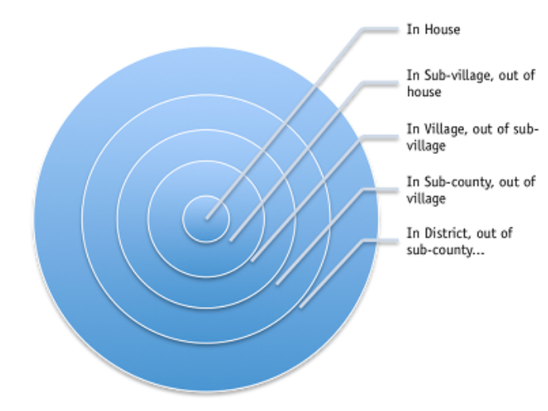
Purpose of this tool is to understand how gender, age, ethnic category and religion affect mobility within the community.
  - Begin by drawing a circle at the center of a large sheet of paper or on the ground. The facilitator should explain that the circle represents the space within the home.
  - Then draw a series of concentric circles as shown in the example for each expanding distance from the home.
  - Ask participants to identify where men and boys can go alone or in pairs, then mark this on the diagram.
  - Then use a different symbol to mark where women and girls can go alone or in pairs. Also mark which locations they can travel to without asking permission. Researchers can ask participants:
- What happens when they reach each successive location away from the home?
- What are the reasons that women and girls would have to travel to that location?
- What types of problems do they face while going to those places?
- How do they manage those problems?
- With whom do they go outside the village?
- How far is it to leave the village?
  - Adapt the categories used to reflect the local community area and repeat the tool for different community groups (for example, by age, ethnicity, religion, caste, or disability).

CARE Gender Toolkit, ‘Social and Resource mapping,’ < http://gendertoolkit.care.org/Pages/Community,%20Social%20and%20Resource%20Mapping.aspx >.
International Rescue Committee, GBV Assessment Tool, ‘Community Mapping,’< http://gbvresponders.org/resources/ >.
CARE Gender Toolkit, ‘Mobility Analysis,’ < http://gendertoolkit.care.org/Pages/mobility%20analysis.aspx >.

