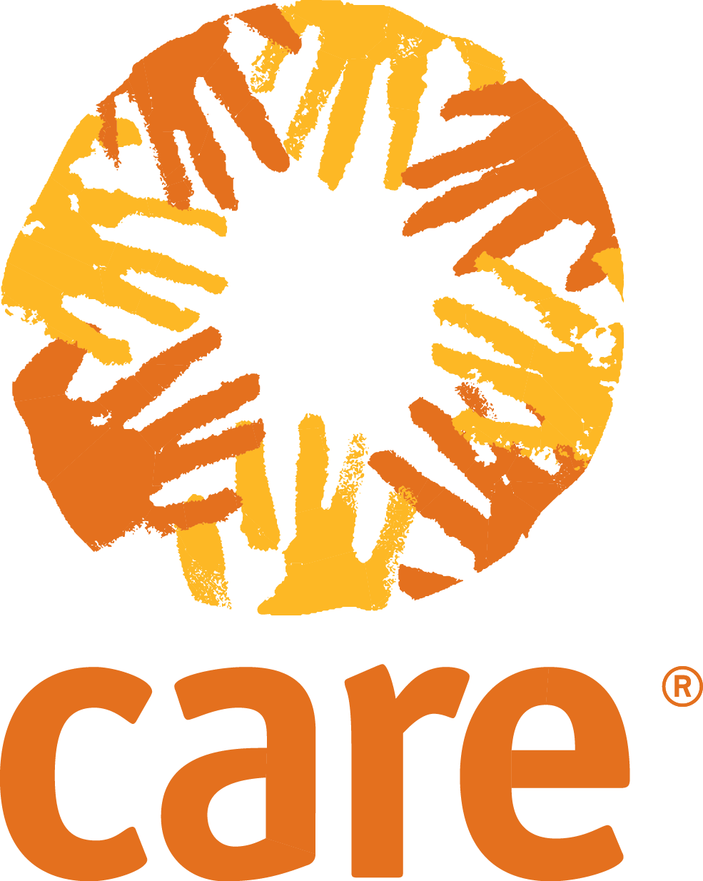

Rapid Gender Analysis: Assessment Tools
Focus Group Discussion
Purpose: Gather information about the opinions, beliefs, practices and attitudes of a group of people towards a specific topic of interest. Guided questions in this Focus Group Discussion (FGD) relate to the roles and responsibilities of women, men, boys and girls; control and access to resources; vulnerabilities and needs; coping; and security concerns.
Tool Notes: This tool should be used during small group discussions. The group should be made of people from similar backgrounds or experiences and should not include more than 10-12 participants. The groups should also be separated by sex and age. The FGD is led by a facilitator who introduces the topics of discussion and helps to ensure that all members participate evenly in the discussions. The facilitator should assure participants that all information shared will remain confidential.
Sector specific questions can be included to gather more detailed information on specific topics relevant to your context or situation.

Geographic Location: Name (optional):
Interview date: Place of interview:
Translation necessary for the interview: Yes No

Introduction

- Thank the informants for participating in interview
- Explain the objectives and expectations of the interview
- Outline the session and the amount of time the interview will take
- Obtain informed consent to record the interview and/or take pictures.

Discussion Questions

- “We would like to ask you about the roles and responsibilities of women, men, boys and girls in your community both now and before the current crisis”.

- Daily Activity Clocks: draw a 24-hour clock
  - Ask the participants to help fill in what a typical day looks like. Including differences that are expressed in the group.

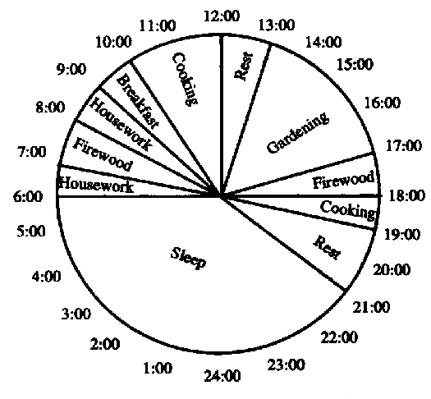
  - What are the main differences in your roles and responsibilities now, compared to before the crisis?

  - Do you have preference for when community meetings or distributions are held?

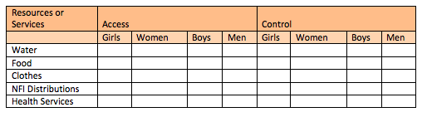
- Control and Access to Resources: draw the template below. Feel free to add more resources or services if needed.

- How are food items and non-food items accessed and controlled by women, men, boys and girls? Use the template to help guide the discussion.

- What has changed since the crisis happened?

- We would like to ask you about who is in need, and what the specific needs of women, men, boys and girls are.

- Who is vulnerable? What are they vulnerable to, and why? What are the different vulnerabilities of women, men, boys and girls?

- What are the needs are of women, men, boys and girls?

- We would now like to ask you about how women, men, boys and girls are coping

- What are the different coping strategies that are used by women, men, boys and girls?

- What are the different skills and capacities of women, men, boys and girls?

- What resources or support are they relying on? How can CARE programme interventions best support these mechanisms?

4. We would like to ask you a few questions about the security of women and girls/men and boys after the crisis (ask the women and girls specific questions in women and girl’s Focus Group Discussions, and men and boys specific questions in men and boys FGDs).

- Within this community, is there a place where women and girls/men and boys feel unsafe or try to avoid? (During the day? Night?) What issues make them feel unsafe?

- When there is a security problem, who can women and girls/men and boys seek assistance from?

- Are there places where women and girls/men and boys can go to voice their security concerns?

- According to you, what could be done in this community to create a safe environment for women and girls/men and boys?

Multi-Agency Gender and Protection Assessment (2014), ‘Kobane Refugee Gender and Protection Assessment Report.
FAO Participatory Assessments http://www.fao.org/docrep/w8016e/w8016e01.htm

