

Rapid Gender Analysis: Assessment Tools
Individual Story
Purpose: Understand the impact of the crisis from the perspective of an affected individual woman, man, boy or girl.
Tool Notes: This tool uses story telling alongside semi-structured interview questions. It is important not to lead the story telling – the hope is that this tool will help to raise issues which may not have been anticipated in designing the assessment. There may be repetition between the information that comes up in the story and some of the interview questions, but ask the interview questions anyway. Remember to get informed consent from your interviewee and ask whether they wish to remain anonymous.

Introduction
- Thank the participant(s) for the interview
- Explain the objectives and expectations of the interview
- Outline the amount of time interview will take
- Obtain the informant’s consent to record the interview and/or take pictures

Geographic location: Interview Date:
Sex of key informant: Male Female Age of key informant:

Story of Change: Affected individuals reflects on changes to gender roles since the crisis

- What changes have you experienced since the crisis?
  - Probe: How were things before the crisis, and how are they different?
  - Probe: What changes have you experienced specifically as a woman/man/boy/girl?

- Of those changes, which is the most significant and why?
  - Probe: Why do these changes matter?

Network Analysis: Coping mechanisms of an affected family or household
Example household map
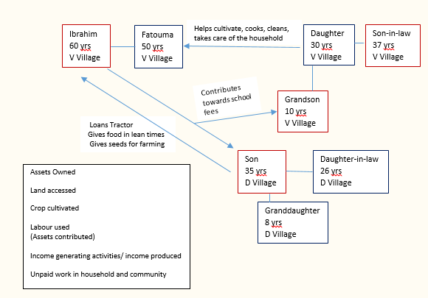
- Create a rough map of the participant’s family/household, starting with the participant. Make sure the interviewee can see your drawing.
- Use a symbol to mark those who have been affected by the crisis.
- Make a record of the diagram.

- Capacities: What resources are the family/household members relying on? What are the different capacities and skills of each member of the family?

- Coping Strategies: What are the different coping mechanisms that family/household members are using?

- Vulnerabilities: Who is vulnerable? What are the different vulnerabilities of women, men, boys and girls?

- Decision Making: How does the household make decisions? Who within the household decides about education, access to health services, household income? Who is not consulted?

Needs

- What are your needs since the crisis happened? What are the needs of other members of your family?
  - Probe: What are the main needs of women and girls, of men and boys?

