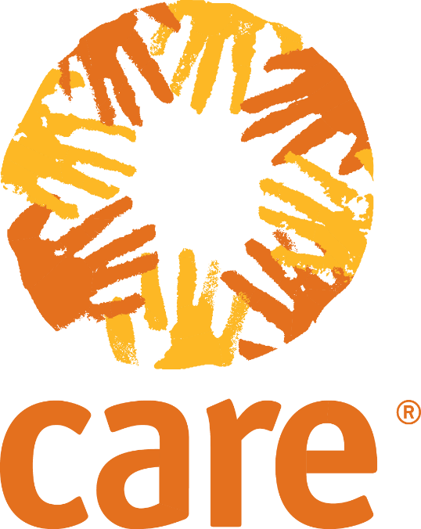

Rapid Gender and Power Analysis: Assessment Tools
Key Informant Interview – CSO & women’s organisations
Purpose: To discover information about people's knowledge, opinions and beliefs relating women’s leadership and participation in governance and decision-making. It can be used with women’s organisations and other civil society organisations, including partners. The tool should be adapted as needed for your context.
Tool Notes: This tool uses the format of semi-structured interviews.

Geographic Location: Name (optional):
Interview date: Place of interview:
Translation necessary for the interview: Yes No

Introduction
- Thank the participant(s) for the interview
- Explain the objectives and expectations of the interview
- Outline the amount of time interview will take
- Obtain the informant’s consent to record the interview and/or take pictures

Sex of key informant: Female Male
Disability status:
Key informant’s organisation and role:

- We would like to ask you about your organisation

1a. What is your organisation’s mission? What does it do?

1b. When was it set up?

1c. What type of organisation is it?

Prompt: NGO, CBO, membership-based? Structure and staff? Decision making body and women’s representation?

1d. Does your organisation work in these communities? Who with? For how long? What activities?

1g. Are there any other women’s or other civil society organisations active in these communities?

- We would like to ask you about women and men access to and participation in public decision-making both before and after the crisis.

2a. What are the main decision-making bodies/spaces that have influence over women’s access to rights, entitlements and resources [in the camp]

2b. Who makes up these decision-making bodies (characteristics, formally or informally) and are they selected?

2c. Who controls decisions in these spaces (informally or formally)

2d. Can women participate in these spaces? Which women?

2e. What influence do women have to these spaces? Which women?

2f. What information do women have about these decision-making bodies?

2g. Do women have ability to make a complaint in relation to these decisions?

- We would like to ask you about the barriers to and opportunities for women’s public decision-making

3a. What constrains women’s participation in decision-making spaces?

3b. Are the barriers different for different spaces/bodies? How?

3c. If women are present in bodies, what constrains their having substantive influence over the decision that are taken?

3d. Has women’s access to decision-making changed since arriving in the camp?

3e. What might increase their ability to influence at family and public decision-making?

- We would like to ask you about women’s aspirations for increased leadership and public decision-making and their needs?

4a. Do you know if women have expressed the desire to be more involved in community governance and decision-making? Which types? Which women?

4b. What would women need to be able to do this?

4c. What activities would support them?

4d. Are you aware of any similar activities that have been tried? What happened?

4.e. Are there any tensions within or between communities? What are the causes of these? Could they be exacerbated by activities to support women’s leadership and participation in decision-making?
If organisation can help complete the next section:

5. We would like to ask you about protection concerns and risks

5a. What are the most significant safety and security concerns for women in this community? (Select all that apply)
No safe place in the community
Sexual violence/abuse
Violence in the home
Risk of attack when traveling outside the community
Risk of attack when going to latrines, local markets, etc. Please specify: ___________________________
Being asked to marry by their families
Trafficking
Unable to access services and resources
Don’t Know
Other:

5b. Do women and girls usually travel outside the community in groups or alone?
Alone/individually
In groups

5c. Do women leaders or women active in public life face increased security and safety risks or any other challenges (stigma and taboo)?

5d. Are there any coping mechanism adopted by men, women, girls and boys in this community to address different protection threats or minimize their protection problems?

5e. Is there any additional support or activities that could be provided to mitigate the risk of violence against women in public life?

5f. When community members have been victims of some form of violence, to whom do they most often go to for help?
Family member
Community leader
Police
NGO working with women
Any female aid worker
UN Agency
Friend
Don’t Know
Other:

5g. Are there reports of sexual abuse or exploitation? Yes No
If yes, by whom?
Government _________________________
Military _________________________
Police _________________________
Peacekeepers _________________________
UN agency _________________________
NGOs _________________________
Other: _________________________

