TOR Photographer/Videographer visit to [LOCATION/CONTEXT] [DATE]

BACKGROUND

[SOME INFO ON HUMANITARIAN SITUATION I.E. FACTS AND FIGURES/DATA AND CARE’S RESPONSE]

ITINERARY

Duration: XX days (including travel days) + XX days editing
Period:

[DAY BY DAY BREAKDOWN OF TRAVEL / LOCATION AND ACTIVITY COVERED IF HAVE]

RENUMERATION

Photographer shall receive the following compensation for the work:

TOTAL of: US $xxx; at a daily rate of US $xxx for shooting and travel days and a reduced rate of US $xxx for editing days

EXPENSES

Photographer shall be reimbursed reasonable expenses for shooting and travel days ONLY: xx days at a rate of XXX [CO TO INSERT DAILY EXPENSES RATE HERE]

SCOPE OF WORK

- The photographer shall capture images of [INSERT THE CONTEXT i.e. destruction from earthquake/displaced people in refugee camp etc]
- Images should include coverage of the general situation showing context of the emergency. Pictures showing ‘urgency’ are welcome. That would be photos showing the (effects of) lack of food, water, medicine, supplies in general in both rural as well as urban areas. In rural areas pictures of (the devastation of) livestock, arable land, orchards et cetera are also welcome.
- Also pictures of ‘resilience’: people finding a way to cope and survive and support each other. Being glad they survived, seeing their family, children playing, togetherness.
- While emphasis should be placed on showing the crisis and humanitarian need the photographer should be sure to shoot images of CARE’s response through our emergency relief (where and if possible), showing how CARE’s work is helping and making a difference. Special attention should be paid to highlighting the plight and role of women and girls in the context of the emergency and CARE’s response. Images should also include CARE staff interacting with program participants in the field and other CARE branding as available.
  - Please ensure you include at least 4-5 images clearly showing the CARE brand in the final submission.
- Photographer will provide detailed captions for each picture including context, location, names and ages as well as Quotes from the subject which cover:
1. specific needs of the person & their family
2. the emotional impact of their situation
3. how help from CARE would change their life
- Images, secondary media and related information captured will be used for a variety of CARE’s communications and fundraising efforts including distribution of images to media outlets covering CARE’s response and presence, and as part of CARE’s effort to raise awareness of the humanitarian crisis. On a daily basis, or at the request of CARE’s communications/media officer, the photographer will provide for upload or email a limited number of JPEG images to support immediate fundraising and communication needs across CI. If needed, specific direction and technical support to facilitate delivery of images in the directed fashion will be provided at that time.

Video Specifications

- The Videographer will capture footage including:
  - scene-setter footage and general b-roll of the area
  - Interviews with women affected by [INSERT NEED/CRISIS] and if possible CARE staff/partner on the ground’s reaction to the situation
    - Short interviews talking about their experiences and the impact of the disaster on them [INSERT SPECIFIC DISASTER] on them
3. Action-oriented b-roll footage of interviewees
    - Interacting with CARE's program work
    - In their homes or jobs
    - Outdoors walking/playing
    - Doing work or chores

All Interviewees need thorough identification in the accompanying log for lower thirds, including name spelled correctly and applicable professional title
- Interview footage and images must be accompanied by consent forms or the person should give permission on camera for CARE to utilize the footage of them. Consent should be acknowledged in the metadata caption.

The photographer should work in close coordination with [INSERT RELEVANT CARE STAFFER NAME] to develop story lines and ensure all needs are being met.

Please allow an addition day(s) for proper filing and delivery of footage; providing a log sheet that lists clip name, short description of what it contains (including names of people featured) and if it's an interview, a summary of what is said (in English).

OBTAINING CONSENT

All consent must be informed. While legally, a signature or mark is important, the policy requires that all Subjects be told, in a clear manner, how any materials may be used in a way that ensures that they fully understand the implications, including how to revoke consent. While a member of CARE staff can assist you in this process, it is important that enough time is factored in for this conversation.

In the case of use by CARE, the Subject(s) – once fully informed - can give consent orally in certain exceptional circumstances, but written consent in the form of a signature or mark is the policy standard.

If the materials are to be used by a corporate partner, consent must be documented. Documented consent is also always required if the Subject is below the age of 18 (a Minor) or is considered vulnerable; such as people living with HIV/AIDS, survivors of female genital cutting, internally displaced persons, survivors of gender-based violence and others who, if their identity were revealed, could be subject to harassment, discrimination or other negative consequences.

If a group of Subjects consent, each member of the group can either sign individually, or a representative of the group can sign, or mark (with an “X” or thumbprint), on the signature page. In the latter case, this must be supported by a note confirming group approval from the CARE Staff or CARE consultant gathering the stories and interviews [Interviewer] or photographer/videographer [Photographer].

ASSESSING RISK TO THE SUBJECT
The levels of risk depend on what the context is, but as a general rule, you should always remove one of the ‘three pillars of risk’ when photographing vulnerable groups such as children:
- face/identity;
- exact location and;
- name

CARE PRACTICE FOR GATHERING CONSENT:

- During the assignment we will also assist you to ensure that people have given their free, prior and informed consent to be photographed or filmed (and their parent or guardian if aged under 18) with or without restrictions. However, it is your responsibility to ensure that this has been done before you film anyone or take their photograph (including for your personal social media channels). People must not be coerced into agreeing to be filmed or photographed.
- Verbal consent is sufficient, providing the subject clearly understands why their photo is being taken, where and how it will be used and the possible risks associated with this. It is good to record consent being obtained, if possible.
- Ensure that any sensitivities or concerns, particularly around anonymity, are clearly recorded and communicated with CARE staff.
- Ensure that all subjects are aware of the process by which they may retract their consent should they wish to do so at a later time.

GENERAL PHOTO GUIDANCE

Preferably
- Not too many people in one picture, a couple of strong individual portraits
- Seeing their faces, at least their eyes
- NOT in a condescending way (so always at the same level, not from a position ‘above’ the subject)
- Always linked in a way to the displacement

- Don’t frame photos too tightly because our typical aspect ratio is 2:1 (and banner slides on the website are nearly 3:1) which is more panoramic than the typical landscape photo aspect ratio.
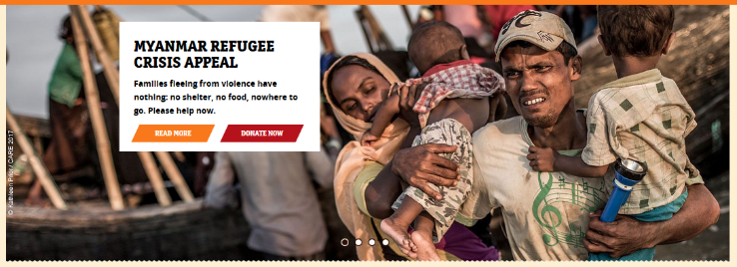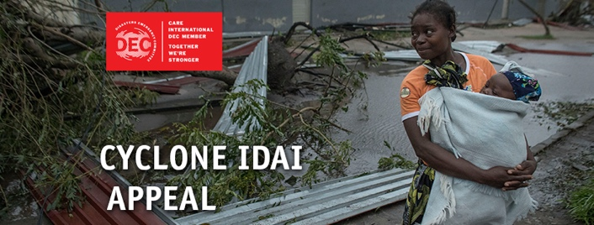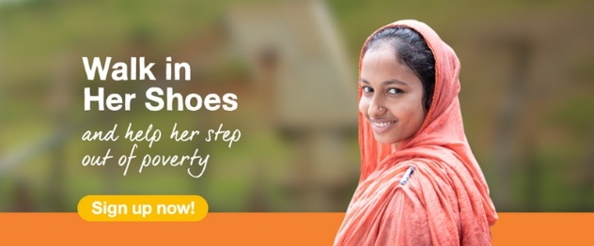

- For banner images on the website and social media, the subject should occupy one-third of the frame and be on the right-hand side, as shown in the examples. Two-thirds of the frame for the background will allow for text/logo overlay. The subject should be strongly positioned, preferable looking to camera and should feature women/girl participants.
- Portrait photos can be ‘posed’ ie the subject of the photo should be looking directly at the camera.
- Contextual photos should be in reportage/documentary style i.e. not look posed and capture the reality.
REQUIREMENTS

Photo requirements:
- Detailed information identifying individuals in the photographs as well as dates, places, ages and relativity to CARE must also be included.
- Images will be made up of high-res JPEGS embedded caption information in the metadata, but photographer should be able to provide raw files on request with.
- The Photographer must employ a current and cross-platform compatible digital work-flow process.
  - For optimal compatibility it is recommended that Adobe Lightroom be used for captioning
  - Photo Mechanic version 4.6.2 or later may be used for captioning and image handling.
  - If an external hard drive is used to deliver images it must be formatted to a FAT (i.e. FAT32) format.
  - Alternate software and/or processes must be discussed and agreed to prior to the start of the commission.
- The Photographer shall deliver to the CARE Images Photo Library the final collection of images in an organized and timely manner, with images labelled using the following naming convention:
  - Country code-Year-Photographer initials-4 digit sequential #
  - Country code to be used shall be: {INDO}
  - Four-digit year format (i.e. 2012, 2013)
  - Example: KEN-2012-EH-0275, KEN-2012-EH-0276
- Images must be accompanied by corresponding caption information, embedded within image files, and all applicable releases.
- Signed CARE consent forms for each subject should be provided alongside images shared.

Video requirements:
Videos should be supplied in original raw files, clearly labelled and filed, and delivered via appropriate file transfer service (dropbox, Google Drive, Box or WeTransfer etc).
- All footage should be recorded in Full HD.
- Interviews should be shot in 25fps.
- All other footage, B Roll, and cutaways should be shot in 60fps.
- A slow moving 60fps close-up shot of the featured woman from each story, making direct eye contact with the camera, while you slowly push in, pan around, etc should be gathered for each woman interviewed. Here are some examples
- Shoot with a shallow depth of field where possible so that the background is slightly out of focus.

