CARE Emergency Preparedness Planning
Guidelines – July 2018

Contents
1 introduction 4
1.1 How to use this guide 5
2 EPP Process 6
2.1 Hazard identification, risk analysis & monitoring 8
2.1.1 Hazard identification and risk analysis 8
2.1.2 Risk monitoring 9
2.2 Emergency Response Team 10
2.3 Capacity assessment 11
2.3.1 Find out more 11
2.4 Contingency or scenario planning 12
2.5 Action planning 13
2.5.1 Minimum preparedness actions 13
2.5.2 Advanced preparedness actions 14
3 EPP Workshop 15
4 Gender in Emergencies 17
4.1 Gender Marker 18
5 Partnership in Emergencies 19
Annex 1 – epp Workbook 21
Annex 2 – How to do risk analysis 22
Annex 2a country risk ratings 24
Annex 3 – how to monitor risk 26
annex 4 – ERT 32
Annex 5 – capacity assessment 33
annex 6 - response planning 34
Annex 7 – minimum preparedness actions 39
Annex 8 – Advanced preparedness actions 40
Annex 9 – gender in emergencies guidance notes 43

Acronyms & glossary
APA | Advanced Preparedness Action | Essential actions to enable a response, taken immediately prior to responding, or at the same time as responding. Also known as readiness actions.
 | Capacity Assessment | A standardised assessment of the capacity of a CARE office to respond to emergencies. Similar to a gap analysis.
CEG | CARE Emergency Group | Part of the CARE Secretariat, responsible for coordinating CARE’s emergency responses.
CET | CARE Emergency Toolkit, www.careemergencytoolkit.org | Comprehensive guidance on CARE’s emergency response protocols, approaches and standards.
CI | CARE International | The Global CARE Federation
CMP | CARE Member Partner | A fully autonomous member of the CARE Federation
CO | Country Office | A CARE office which is managed by a CARE Member Partner
CTP | Cash transfer programming | All programming involving the distribution of cash or vouchers.
EPP | Emergency Preparedness Planning
ERF | Emergency Response Fund | A central revolving fund administered by CARE Emergency Group which can make rapid disbursements of funds to enable response by CARE offices.
 | Hazard | Anything with the potential to cause harm.
IASC | Inter-Agency Standing Committee | The primary mechanism for inter-agency coordination of humanitarian assistance, with representation from UN agencies, Red Cross/Red Crescent & INGOs.
LM | Lead Member | A CARE Member Partner which managers CARE Country Offices (not all do).
MPA | Minimum Preparedness Action | Actions which must be taken periodically, or during the day-to-day business of CARE Offices, to maintain an ability to respond to emergencies.
RHC | Regional Humanitarian Coordinator | A member of CARE Emergency Group staff responsible for coordinating and supporting humanitarian capacity and response in CARE offices in particular regions.
RRT | Rapid Response Team | CARE’s global team of deployable humanitarian experts, managed by CARE Canada.
 | Risk | The likelihood of a hazard causing harm
 | Scenario-based response planning | Planning based on likely disaster scenarios. Also known as contingency planning.

introduction
These Guidelines are designed to assist CARE International to carry out emergency preparedness planning (EPP) in the countries where it has a presence. The guidelines are an integral part of CARE Emergency Toolkit (CET) and build on various chapters of the CET to provide guidance on country-level emergency preparedness.
Emergency preparedness is not a stand-alone, one-off activity. It is a process that is developed and adapted alongside and according to a country’s risk profile, the humanitarian situation on the ground and the operational capacity of CARE and its partners. The approach put forward in these guidelines builds on the Inter-Agency Standing Committee’s (IASC’s) guide for Emergency Response Preparedness.The analysis developed in emergency preparedness plans should also inform long-term strategic plans as much as possible. EPP is a planning tool that builds upon, complements and contributes to the CARE programs and long-term strategic planning. It also informs programs, teams and individual staff. Therefore, it is both appropriate and recommended that countries review and update their EPPs prior to annual strategic planning exercises. In high risk and very high risk countries, review of the EPP prior to annual strategic planning is mandatory.
Emergency preparedness in CARE must address gender in emergencies and define how CARE works in partnership with other organizations. Specific sections on these topics are included in this guidance.
Risk ranking and emergency preparedness planning requires CARE and its partners to work with uncertainty. We are unlikely to develop a scenario that perfectly predicts future events. Risk management and emergency preparedness are most effective when we develop scenarios together with partners that allow us to make adaptable, scalable, living response plans that inform overall country level operations and programs.
Successful EPPs must be inclusive. Development and revision of EPPs should include representatives from partner organizations, from program and program support staff, and from capital office and field office teams. There should be a reasonable balance of male and female staff members, as well as diversity in the seniority of staff included.
In some cases, where CARE may have a large footprint and/or remote field offices, it may be useful to develop separate EPPs for the field offices. It is possible to develop the field level EPPs first and use those to inform the development of the overall country EPP or the country level EPP can be developed first and then cascaded to field offices. Countries should use their discretion about which order of EPP development would be most useful in their operating context. Similarly, sub-regional and regional EPPs may be useful to address large-scale emergencies, especially those that are likely to result in the displacement of populations across borders or in countries where CARE has no presence.

How to use this guide
Each section of this guide starts with an overview of the preparedness expectations for low, medium and high risk offices, using this format:
Low risk | Low risk office expectations
Medium risk | Medium risk office expectations
High risk | High risk office expectations

This is then followed with a description of the key activities that need to be undertaken to meet the expectations.
Further detailed guidance is included in annexes and references are made to the relevant parts of the CARE Emergency Toolkit. The annexes are either included in full in this document, or a link is provided to a separate file on the CARE Emergency Toolkit. The separate annexes can be downloaded together in a single zip file here.
Risk rating by country can be found in Annex 2A – Country Risk Rating, and will be updated annually. If you have not received it please contact Losane Retta at retta@careinternational.org.
For any questions, assistance or feedback on EPP guidelines and process please contact Debbie Santalesa, CARE’s EPP Manager, at debbie.santalesa@care.org, or your Regional Humanitarian Coordinator (RHC).

 | When you see this symbol, it tells you how to use the CARE EPP Workbook to do what you have been reading about.

 | When you see this symbol, it means that this is a particularly important point to consider.

EPP Process
Table 1: Elements of the CARE EPP Process
What | When | Where
 |  | Low risk | Medium risk | High risk
Hazard identification and risk analysis | Annually | All offices must periodically analyse their context and risks to ensure appropriate levels of preparedness.
Capacity assessment | Annually | Standard capacity assessment and gap analysis
Scenario-based response planning | Annually, or if disaster if imminent. | Selection of response sectors and high-level interventions only |  | Required
Minimum preparedness actions (MPAs) | Continuously | CARE has mandated MPAs for offices based on their level of risk. Offices should develop additional MPAs based on their capacity assessment and gap analysis.
Risk monitoring | Continuously | Informal monitoring of context and situation. |  | Formal, systematic risk monitoring.
Advanced preparedness actions (APAs) | When a disaster is imminent. | CARE has a set of basic APAs, included in the Emergency Pocketbook, which should be implemented in the case of an alert being raised. |  | Additional specific APAs for scenario-based plans may be developed.

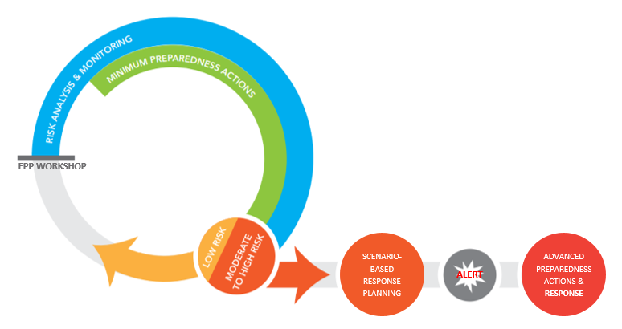
Figure 1: CARE EPP diagram, based on a modified IASC model for emergency preparedness.
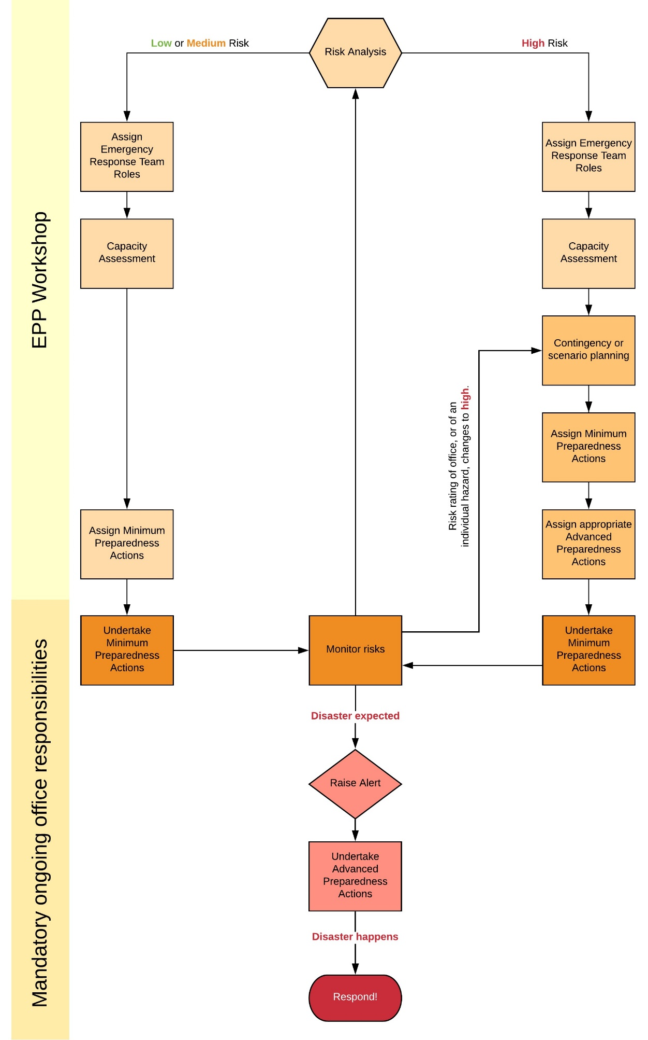
Figure 2: CARE EPP Flowchart

Hazard identification, risk analysis & monitoring

Hazard identification and risk analysis
Low risk  Medium risk  High risk | All offices must undertake periodic hazard identification and risk analysis to ensure they do not need to increase their risk rating and invest more in preparedness.
A hazard is anything that may cause harm. For example, flooding, conflict, drought, pests, disease.
A risk is the likelihood of something (a hazard) causing harm. Risk may be expressed as low, medium, high, or with a probability, or a percentage.
Identifying hazards, and analysing the risk they pose, is an essential component of preparedness; it provides both a common understanding of risks as well as a process to prioritise those risks and decide which to prepare for most. CARE offices should identify the main hazards that may trigger a crisis and harm people in their country of operation and rank them as low, medium, or high risk, considering both the impact they may have, and the likelihood of them occurring.
Do:
- Use easily available information, such as INFORM, and national risk analysis from ministries, meteorological department and disaster management agencies to identify your hazards and support your analysis.
- Regularly review the risk analysis (in accordance with CARE’s Minimum Preparedness Actions) to ensure that changing contexts do not require updates to your planning.
- Involve your partners in the hazard identification and risk analysis. They are likely to have local knowledge and information which could change and improve your analysis.
- Consider the impact of emergencies on women, girls, men and boys when ranking the likely impact of an emergency. Use your Gender in Brief and, if available, relevant Rapid Gender Analyses (RGAs) to inform your analysis.
Do not:
- Attempt to use primary data or do original research into hazards and risk. Good information is almost always available from expert sources (e.g. INFORM).
- Do statistical analysis or use calculations of probability without input from appropriate experts.

Find out more
See Annex 2 for detailed guidance and Annex 2A for country risk ratings, including guidance on how to fill in the CARE EPP Workbook section 3.1.

Risk monitoring
Low risk  Medium risk | The senior staff of the office should be aware of current affairs and engage in relevant coordination bodies and fora which would make them aware of significant changes to the risk level in country. There is no need to fill in the risk monitoring matrix in the EPP workbook.
High risk | A formal risk monitoring system should be in place to monitor the risks which are most likely or would have high impact. The risk monitoring matrix in the EPP workbook, or the Alert risk monitoring module, must be used.
In high risk offices, a risk monitoring mechanism should be established to track hazards that have been identified in the risk analysis. Any hazards associated with a medium to high risk should be regularly monitored. Monitoring provides early warning of emerging risks, which in turn allows for early action. Risk monitoring should be undertaken using indicators as part of the risk analysis process.
Do:
- Monitor indicators which are SMART:
  - Specific: it should be very clear what is being measured, there should be no ambiguity.
  - Measurable: it should be possible to objectively measure them.
  - Achievable: it should be easy to find the necessary information.
  - Relevant: the indicator should give you a reliable insight into the risk of the hazard you are monitoring.
  - Time-bound: you should update the indicator with an appropriate frequency.
- Monitor information produced by disaster management agencies, ministries or other organizations which are already collecting necessary information. Where available, sex- and/or age-disaggregated data will enhance your gender and, therefore, overall analysis.
- Involve your partners and field staff in monitoring; they are likely to have access to valuable local information which is missed by national risk monitoring. They are the eyes and ears of CARE on the ground.
- For each indicator, identify trigger values which will require the indicator to be monitored more frequently (amber), or will require action to be taken (red). Ask “what events or changes in the situation would make it necessary to increase our level of preparedness to respond?”
- Consider if there are specific gender-related indicators which CARE should be monitoring (e.g. incidence of GBV, maternal mortality).
Do not:
- Duplicate monitoring already carried out by others. Use their monitoring instead.
- Monitor indicators which do not provide you with additional insights over what you can find out from secondary sources.
- Monitor too many indicators.

Find out more
See Annex 3 for detailed guidance, including guidance on how to fill in the CARE EPP Workbook section 3.2.

Emergency Response Team
Low risk | Low risk offices must have an identified emergency response focal point to act as coordinator in the case of a response being needed.
Medium risk | Medium risk offices must have an emergency response coordinator and minimum key roles on an emergency response team (ERT) identified.
High risk | High risk offices must have a full-time dedicated Emergency Response Coordinator and all key roles on the emergency response team identified.
Every CO Member or Affiliate is required to have a functioning ERT, which, depending on the presence model, will be composed of CARE staff and, where the expected delivery model includes a partnership approach, partner representatives.
The ERT is usually led by the Emergency Response Team Coordinator, but may be led by the Country Director/National Director or Assistant Country/Program Director, supported by the Emergency Response Team Coordinator. The team is responsible for coordinating country level activities for emergency preparedness and response with the aim of delivering high quality emergency responses of an appropriate scale to populations in need. The ERT is usually composed of existing staff that will likely have to take up a ‘shadow’ role during an emergency. For example, if there is no dedicated Emergency Response Coordinator, the ACD/PQ is usually designated as the ERT Coordinator.
For ERT tasks during an emergency, please refer to section and to the CARE Emergency Toolkit: https://www.careemergencytoolkit.org/getting-going/2-basic-guide/. Note that these tasks are in fact Advanced Preparedness Actions.
Do:
- Pay particular attention to ensuring you have people in place to take part in humanitarian coordination. It is important that the ERT and CARE partners understand the Cluster System and the specifics of humanitarian coordination in the country in question. CARE and its partners should engage in any coordination or national clusters which are active in non-emergency situations. Participation in coordination mechanisms increases CARE’s visibility and credibility and has a direct link to the likelihood of receiving funding when needed.
- Ensure all members of the ERT have received an induction on the CARE Emergency Toolkit
- Ensure ERT members roles are included in their job descriptions.
- Identify back-up staff for key ERT positions in case of staff absence.
- Ensure the ERT includes at least 40% female staff. In preparedness, ensure that any culturally-appropriate accommodating measures, necessary to ensure this gender balance, are in place.

Find out more
See Annex 4 for detailed guidance.

Capacity assessment
Low risk  Medium risk | Low and medium risk offices should complete a capacity assessment.
High risk | High risk offices should complete a capacity assessment and develop an action plan (additional MPAs) to address any key gaps in capacity identified.
A capacity assessment must be undertaken to inform what areas a CARE office is able to respond in with and without external support. It is important that humanitarian response is based on needs, and not just on CARE’s local capacity. The capacity assessment is an essential tool in planning such a needs-based response and identifying gaps that need to be filled. The capacity assessment will allow the CARE office to decide which Minimum Preparedness Actions it needs to complete, in addition to those mandated by CARE International.
In this spirit, the focus of the capacity assessment should be on collective capacity to respond. CARE may not have all the capacity itself; some capacity to respond may sit with CARE partners. Recognising this ahead of the emergency will ensure that the wider CARE world can also be made aware, facilitating rapid and relevant support to the emergency.
Do:
- Discuss and complete the Capacity Assessment Questionnaire (Protocol C3) (Annex 6). In the case of a traditional Country Office, when an emergency occurs, return the completed form to the Lead Member (line manager, RMU and Emergency Director) and CEG; in the case of an affiliate member, return just to CEG.
- Undertake a capacity assessment with each identified partner for emergency response and enter this in the EPP Workbook Partnerships Matrix.
- Review the emergency capacity building matrix to identify minimum preparedness actions (MPAs) needed, and to help guide office workshops and training.
Do not:
- Underestimate the time needed to do a capacity assessment. In a workshop, split the parts of the team between the attendees to reduce the time needed.

Find out more
See Annex 5 for the capacity assessment questionnaire and Annex 5a for the capacity building activities.

Contingency or scenario planning
Low risk  Medium risk | Low & medium risk offices do not need to do scenario-based response planning. They should select sectors and primary interventions only based on their capacity assessment and risk analysis.
High risk | High risk offices should complete a more detailed scenario-based response plan for their highest priority risks.
Based on the risk analysis and capacity assessment, high risk offices should make plans for the most likely or highest impact emergencies they anticipate having to respond to. For offices currently responding to an emergency, you may want to focus primarily on contingency planning or ‘scenario-based response plans’ to identify other potential emergencies or changes in context that will require a new or different responses(s). These ‘scenario-based response plans’ will form the basis of a response, and enable CARE to make rapid decisions, and start responding rapidly, when these emergencies occur. Scenario-based plans can be developed to different levels of detail, and a decision should be taken by the CARE office as to how detailed the plans should be. As a minimum they should include:
- The sectors in which to respond (and this must include at least one CARE core sector – so WASH, shelter, sexual & reproductive health (SRH) or food & nutrition security).
- The main activities, within the selected sectors.
- The mode of intervention: direct implementation, implementation by partners, or mixed.
- The scale of the response: the target numbers of people and the overall budget
- The location(s) of the response
- How the response will meet the distinct needs of women, girls, men and boys, and any identified vulnerable groups.
Do:
- Use the Gender in Brief and, if available, any relevant Rapid Gender Analyses developed earlier.
- Decide if the scenario is a Type 1, 2 or 4 response to inform your planning
- Identify actions that need to be taken well in advance (MPAs), or when a response is imminent (APAs), to enable the plan.
- Include at least one core sector in your plan and involve the relevant global sector leads and, in all cases, the Gender in Emergencies Coordinator (Operations).
- Ensure proposed interventions align with CI Standards (see the CARE Emergency Toolkit)
- Involve key partners in the planning.
- Consider your long-term programming when planning. How can it support your preparedness, risk reduction, and response, and how will your response relate to long-term programming?
Do not:
- Go into unnecessary detail. Plan sufficiently to enable key decisions to be taken, and no more.
- Target only your existing impact groups without considering how the emergency might change needs and vulnerabilities. Humanitarian response should be needs-based.

Find out more
See Annex 6 for detailed guidance, including guidance on how to fill in sections 3 and 4 of the CARE EPP Workbook

Action planning

Minimum preparedness actions
Low risk  Medium risk | Low and medium risk offices should complete the basic set of minimum preparedness actions, and any additional actions identified as necessary during the planning. MPAs should be reviewed annually.
High risk | High risk offices should complete the high risk set of minimum preparedness actions, and any additional actions identified as necessary during the planning. MPAs should be reviewed quarterly.
Minimum preparedness actions (MPAs) are actions taken on a day to day basis which will ensure operational continuity and effective response when an emergency occurs.
CARE has a list of mandated Minimum Preparedness Actions which CARE offices must implement.
Lead members may require additional MPAs for their offices.
CARE offices can add additional MPAs based on their capacity assessment and scenario-based planning.
 | Additional MPAs should be listed in section 5 of the CARE EPP Workbook
Do:
- Add MPAs to section 5 of the workbook to address key gaps in capacity identified in the capacity assessment and scenario-based planning.
- Ensure all MPAs are assigned to a named member of staff.
- Regularly review the status of all MPAs, quarterly or annually depending on the risk level of the office.
- Ensure there are MPAs both for program and for program support departments.
Do not:
- Have too many MPAs in addition to those required by CARE. Select a small number of additional, essential actions to ensure your action plan is realistic.

Find out more
See Annex 7 for lists of CARE mandated and additional MPAs.

Advanced preparedness actions
Low risk  Medium risk | When a response is needed, low and medium risk offices should use the CARE Advanced Preparedness Actions outlined in the CARE Emergency Pocketbook.
High risk | High risk offices should identify key Advanced Preparedness Actions (APAs) in accordance with their scenario-based plans, an addition to the CARE Advanced Preparedness Actions outlined in the CARE Emergency Pocketbook. All APAs should be assigned to ERT members.
Advanced preparedness actions (APAs) are actions which, if early warning allows, immediately precede emergency response, in order to limit impacts and ensure an advanced state of readiness to respond. Where early warning does not allow, APAs are carried out in parallel with response.
Consider what actions you cannot do far in advance, but must do very quickly to enable a response to happen: these are your Advanced Preparedness Actions. The actions in the CARE Emergency Pocketbook are CARE’s standard APAs: https://www.careemergencytoolkit.org/getting-going/2-basic-guide/. All CARE offices implementing responses must carry out these actions as soon as they decide to mount a response, or raise an alert.
Additional APAs may be identified based on scenario-based plans.
Do:
- Assign APAs to Emergency Response Team members during your planning, so when you need to respond, people know what their responsibilities are.
- Select and assign APAs specifically related to your planned responses. For example, if you plan to undertake distributions, one APA will be to source trucks to transport the items.
Do not:
- Have a long list of APAs which you cannot realistically do within a short time of activating your response. Prioritise and focus on the key actions that must be done, quickly, to enable a response.

Find out more
See Annex 8 for the list of CARE mandated APAs. See also the CARE Emergency Pocketbook and CARE Emergency Toolkit.

EPP Workshop
Low risk | Low risk offices must have an EPP workshop every 2 years.
Medium risk | Medium risk offices must have an annual EPP workshop.
High risk | High risk offices must have an annual EPP workshop of at least 3 days’ duration.
EPP workshops are mandatory. Conducting an EPP workshop is one of CARE’s mandated Minimum Preparedness Actions.
The country context and preparedness needs should drive the workshop agenda. Past experience shows that workshops should be designed both to deliver orientation and training to the Emergency Response Team (ERT) and to conduct participatory planning. Workshop design should include small group exercises to achieve initial thinking and larger group work for capacity building and validation of plans. The Regional Humanitarian Coordinator, Global Sector Leads, and key members of the Rapid Response Team (RRT) and CARE member emergency units are additional resources for facilitation and guidance on EPP workshop design and facilitation.
As a minimum, an EPP workshop must include:
- Review and allocation of ERT roles
- Review and update to the capacity assessment
- Review and update to the hazard identification and risk analysis
- For high risk offices: scenario-based response planning
- Review and updating of the Minimum Preparedness Actions
- Review and updating of the EPP Workbook
The main outputs from an EPP Workshop are an up to date EPP Workbook and an agreed list of Minimum Preparedness Actions. These should be completed and shared with CEG, and Lead Member if applicable, within 1 month of the EPP Workshop.
On the next page example agendas for 2-day, 3-day and 4-day EPP workshops are presented. Agendas should be tailored to suit the requirements of the CARE office in question. High risk offices should allocate at least 3 days to their EPP workshop.

Find out more
See Annex 1 for the CARE EPP Workbook.
 | Day 1 | Day 2
Morning | Introductions and country context | Partnership in emergencies
Morning | Hazard identification and risk analysis | Gender in emergencies
Morning | Hazard identification and risk analysis | Action planning: minimum preparedness actions
Lunch
Afternoon | ERT roles | Action planning: minimum preparedness actions
Afternoon | Capacity assessment | Wrap up

 | Day 1 | Day 2 | Day 3
Morning | Introductions & country context | Response exercise | Partnership in emergencies
Morning | Hazard identification & risk analysis | Scenario-based response planning | Action planning: minimum preparedness actions
Lunch
Afternoon | ERT roles | Scenario-based response planning | Further action planning (MPAs or APAs).
Afternoon | Capacity assessment | Gender in Emergencies | Wrap up

 | Day 1 | Day 2 | Day 3 | Day 4
Morning | Introductions & country context | Response simulation | Scenario-based response planning | Partnership in emergencies
Morning | Hazard identification & risk analysis | Response simulation | Scenario-based response planning | Action planning: minimum preparedness actions
Lunch
Afternoon | ERT roles | Response simulation | Scenario-based response planning | Further action planning (MPAs or APAs).
Afternoon | Capacity assessment | Debrief | Gender in Emergencies | Wrap up

Gender in Emergencies
Low risk  Medium risk | Low and medium risk offices must have a Gender in Brief and review it on an annual basis to ensure that it contains the most current data and information.
High risk | High risk offices must have a Gender in Brief and review it on an annual basis; and ensure that the data and information from the Gender in Brief, together with the findings from any Rapid Gender Analyses from the same area of intervention inform specific additional Gender MPAs.

Gender integration is a core element of CARE’s EPP process. Integrating gender means that countries are prepared to meet the different needs of women, men, boys and girls affected by disasters.
CARE and its partners must have a clear understanding of the gender relations among those affected by emergencies and the different effects that previous crises had on women, men, boys and girls. This information is summarised in the Gender in Brief and, if available, in previous Rapid Gender Analyses conducted in the same area of intervention. This is critical in order to most effectively interpret the differing risk profiles of women, men, girls and boys and to develop the Rapid Gender Analysis.
CARE has developed Gender Minimum Preparedness Actions. These ensure that gender is integrated into humanitarian response and into operational readiness. They are included in the MPA list in Annex 6.
Do:
- Ensure that the office regularly uses the CARE Gender Marker on all projects and programs. If you are scoring grade 2 or above in day-to-day programming, the office will be better prepared and equipped to integrate gender in emergency responses. As a CARE global program approach, this is something that should be happening anyway. See below for more details on the Gender Marker.
- Consider which additional Gender MPAs the office has the capacity to undertake, in addition to the CI mandated MPAs. See the Gender in Emergencies Preparedness Planning Guidance note.
- Include a Gender in Emergencies session and/or training in the EPP workshop.
- Ensure some of your partners are women’s organizations or, at the very minimum, have good gender balance and a gender focus.
Do not:
- Have a long list of additional Gender MPAs or APAs which the ERT does not have the capacity to implement or which you cannot realistically do within a short time of activating your response. Prioritise and focus on the key actions that can be done well and done consistently to strengthen the response.
- Do not ignore the advice of women’s organization partners in the development/review of the Gender in Brief and the contextualization of the Gender MPAs.

Gender Marker
Using the CARE Gender Marker, CARE monitors how effectively gender is integrated into preparedness work and evaluates to what extent gender‐sensitive preparedness translates into a gender‐sensitive, gender-responsive or gender-transformative response. The Gender Marker is an internal accountability tool that assists CARE to ensure that minimum standards of gender equality are met in programming; to measure change; to increase accountability to meet strategic goals on gender equality; and to improve programming by making it easier to identify weaknesses and, therefore, to make necessary adaptions.
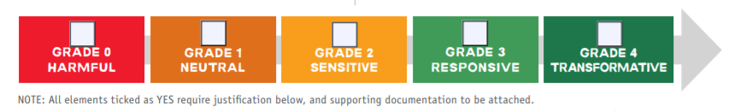
f
Figure 3: CARE Gender continuum
Specific guidance on using Gender Marker is here.
CARE staff should know how to use the Gender Marker and be ready to use it as an accountability tool in humanitarian responses.

Find out more
See the gender section of the CARE Emergency Toolkit.
See the Gender in Emergencies Guidance Note Series, including:
- Gender in Emergency Preparedness Planning Guidance Note.
- Gender in Brief Guidance Note.
- Gender Action Plan Guidance Notes.
These are also included in Annexes 9a, 9b and 9c.

Partnership in Emergencies
Low risk  Medium risk | Low and medium risk countries must have identified the optimal mode of delivery (direct, mixed, or with partners), and as appropriate, a partnership portfolio.
High risk | High risk countries must be proactive in engaging select partners in emergency preparedness, through joint planning and preparations to respond together, and capacity strengthening.

CARE’s emergency work is increasingly delivered with partners and seeks to build upon – not replace – existing local capacities. CARE recommends pro-actively engaging local actors (government, civil society, private sector as appropriate) in emergency preparedness (not as an afterthought). Scoping the potential for partnership and planning jointly with partners are critical to effective and increasingly localized disaster response.
Based on CARE’s Localizing Aid and Partnership commitments, providing life-saving assistance is increasingly seen as the responsibility of local frontline responders, supported by – and not led by – international organizations. The optimal approach is for CARE and its partners to maximize their respective comparative advantage to deliver complementary or joint responses that empower affected populations and local actors. Direct implementation will continue to be required in certain cases, but we need to be more intentional as to where and when it becomes the preferred mode of delivery (and justify why).
We must remember that partnerships are means to an end, not an end in themselves. We partner because collectively, we feel we can achieve more for affected communities than we would alone. Partnerships offer a model of working that draws on the unique expertise, attributes and resources that different agencies offer.
Engaging partners in preparedness should not be done in a vacuum. It is important to review the strategic directions and intent of the Country Office when it comes to partnership: What are the CO (or CMP, or region) partnership aspirations, approach and current partnership portfolio? Engaging partners in the preparedness process should reflect and advance these aspirations, and partners should influence them.
The quality of the joint response (CARE and partners) will only be as good as the partnership that underpins it. We need to pay attention to how we work together, not just what we will do together. Building strong and productive relationships requires time, effort, risk sharing and two-way communication. We need to invest in the partnering process itself and this is best done during the preparedness phase.
CARE has developed Partnership Minimum Preparedness Actions. These ensure that partnership is integrated into humanitarian response and into operational readiness. They are included in the MPA list which can be found in Annex 6. Because not all CARE offices plan to respond with partners, the Partnership MPAs are not all mandatory, but CARE offices planning to work in partnership should implement them.
Engaging partners in emergency preparedness planning should result in increased:
- Predictability of the joint response: how we will respond together and what we will do jointly
- Readiness to activate and scale up the partnership
- Capacity and readiness to respond jointly for both CARE and partner agencies.
Do:
- Ensure that the overall partnership vision/intent of the CO is reflected in humanitarian preparedness and response (engaging partners in preparedness should be true to, and advance, these aspirations).
- Ensure that planned interventions identify the optimal mode of delivery. Responses should involve, and increasingly be led by, local actors.
- Map existing local actors and capacities for humanitarian response and build upon them. Select an optimal portfolio of partners.
- Include identified local partners in preparedness planning, as part of the workshop, risk monitoring, capacity assessment, and response planning.
- Include a Partnership session in the EPP workshop.
- Develop capacity building plans with your partners, including CARE building the partners’ capacity, and the partners building CARE’s capacity.
- Put memorandums of understanding in place with key identified partners for humanitarian response.
- Invest in relationship building with partners, building understanding and trust.
- Consider which additional Partnerships MPAs the office has the capacity to undertake, in addition to the CI recommended and mandated MPAs.
Do not:
- Ignore, undermine or undervalue existing local capacity to respond (capacity often exists and should be sought, mapped, supported).
- Work with too many, non-strategic, partners in the preparedness phase as this will stretch your resources for planning and capacity building.
- Underestimate the time and effort needed to build strong partnerships.
- Choose emergency response partners in isolation from your scenario-based response plans. Your chosen sectors, geographic areas and modalities of response need to match your partners’ presence and capacities.

Find out more
See the Partnership section of the CARE Emergency Toolkit.
Annex 1 – epp Workbook
Use the EPP workbook as a template for your country EPP document. The endorsement process for the EPP requires sign-off for a country office is from the Country Director (CD), the CD’s line manager, the Regional Humanitarian Coordinator (RHC), and the LM Emergency Unit. Members/Affiliates should ensure that the RHC is included in the finalization of the document.
https://www.careemergencytoolkit.org/wp-content/uploads/2017/03/Annex-1-CARE-Emergency-Preparedness-Planning-Workbook.docx

Annex 2 – How to do risk analysis
The steps outlined above should be reflected in the CARE EPP Workbook in Table 2: Hazard and annual analysis of risk level.
Each CARE office must complete two key steps to analyse the risk of an emergency occurring:
- The hazards which might occur need to be identified. They may include:
  - Natural hazards, either:
    - hydro-meteorological (weather related, so: floods, landslides, storms, droughts)
    - geophysical (earthquakes, volcanic eruptions, tsunamis)
  - Armed conflict and civil unrest
  - Epidemics and pandemics (disease).
  - Drastic changes in the socio-economic environment (surges in prices of essential goods, restrictive government legislation, economic blockades, etc.)
  - Serious violations of international human rights law or international humanitarian law.
  - Environmental hazards (industrial accidents, severe pollution, fire, etc.).
To identify which hazards are possible, review the historical data on disasters in the area (in country or across borders if applicable). Together with the INFORM data, compare historical data with climactic trends and projections; consider additional data such as population growth and other demographic changes, ecosystems degradation and economic changes and use this combined information to identify potential hazards that may occur within the next year(s).
- The risk posed by the hazards identified needs to be evaluated, and the risks ranked accordingly. This is a three-stage process:
  - The likelihood of the hazard occurring is evaluated, and ranked on a scale of 1 to 5 (where 5 is the most likely). See Table 2 on the next page for guidance on ranking.
  - The impact of the hazard, if it should occur, is evaluated, and ranked on a scale of 1 to 5 (where 5 is the most severe impact). See Table 2 on the next page for guidance on ranking.
  - The two numbers representing likelihood and impact are multiplied for each hazard, giving an overall measure of the risk posed by that hazard on a scale of 1 to 25 (where 25 is the worst). The hazards are then categorised as follows:

Risk category | Risk score
Low | 1-7
Medium | 8-14
High | 15-25
The highest-risk hazards are those that have both a high probability of occurring and a high impact if they occur.
Table 2: Risk ranking guidance
Score | Likelihood (probability of occurrence) | Impact (severity)
1 | Very unlikely  A remote chance of an event occurring in the current year, from 0-5%. | Negligible  Minor additional humanitarian impact. Local capacity is sufficient to deal with the situation.
2 | Unlikely  The event has a low chance of arising in the current year, from 5 to 15%. | Minor  Minor additional humanitarian impact. Current country level inter-agency resources sufficient to cover needs beyond local capacity. Type 1 scale emergency
3 | Moderately likely  The event has a viable chance of arising in the current year, from 15-30%. | Moderate  Moderate additional humanitarian impact. New resources up to 30% of current operations needed to cover needs beyond local capacity. Type 1/2 scale emergency.
4 | Likely  The event has a significant chance of arising in the current year, from 30-50%. | Severe  Substantive additional humanitarian impact. New resources up to 50% of current operations needed to cover needs beyond local capacity. International support needed. Type 2 scale emergency.
5 | Very likely, or certain  The event has a positive chance of arising, over 50%. | Critical  Massive additional humanitarian impact. New resources over 80% of current operations needed to cover needs beyond local capacity. Type 4 scale emergency

Ranking using this scale is subjective and uncertain, and will vary depending on who is doing the ranking. Using scientific data and information from reputable sources supports a higher quality of risk ranking. It is important that a consistent approach and process is used, and relevant and up to date information is sought from appropriate sources, including local partners familiar with the situation on the ground.
Calculating the likelihood of a hazard occurring
Uncertainty from climate change
Climate change means that great caution has to be taken when using historic data about climatic and hydro-meteorological events. It is unlikely that historic patterns can be relied upon to continue into the near or distant future.
Example of Table 2 from the CARE EPP Workbook:
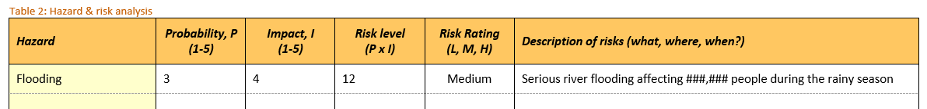
Annex 2a country risk ratings
CY 2018 RISK RANKING
2018 Risk Ranking from Index For Risk Management (INFORM) (http://www.inform-index.org)
REGION | Very High | High |  | Medium Risk |  | Lower Risk
Asia /Pacific | Afghanistan ^^ | Bangladesh |  | Cambodia |  | Fiji *
Asia /Pacific |  | India |  | Indonesia
Asia /Pacific |  | Myanmar |  | Lao PDR
Asia /Pacific |  | Nepal ^^ |  | Timor-Leste
Asia /Pacific |  | Pakistan ^^ |  | Vanuatu
Asia /Pacific |  | Papua New Guinea |  | Vietnam
Asia /Pacific |  | Philippines |  | Sri Lanka
Asia /Pacific |  |  |  | Thailand
East, Central and Southern Africa | DRC * (T4) | Burundi* ^^ |  | Malawi
East, Central and Southern Africa | Somalia (RT4) | Ethiopia (RT4) |  | South Africa
East, Central and Southern Africa | South Sudan * (T4) | Kenya (RT4) |  | Zambia
East, Central and Southern Africa | Sudan ^^ | Tanzania
East, Central and Southern Africa |  | Rwanda *
East, Central and Southern Africa |  | Uganda
East, Central and Southern Africa |  | Mozambique
East, Central and Southern Africa |  | Madagascar
East, Central and Southern Africa |  | Zimbabwe ^^
West Africa | Chad * (RT4) | Cote d'ivoire |  | Ghana
West Africa | Niger * (RT4) | Cameroon* (RT4) |  | Benin/Togo *
West Africa |  | Mali ^^
West Africa |  | Nigeria (RT4)
West Africa |  | Sierra Leone * ^^
MENA | Iraq (T4) | Turkey* ^^ |  | Balkans |  | Greece
MENA | Syria (T4) |  |  | OPt (WBG) ^^
MENA | Yemen * (T4) |  |  | Jordan ^^
MENA |  |  |  | Egypt
MENA |  |  |  | Morocco*
MENA |  |  |  | Caucasus
MENA |  |  |  | Lebanon ^^
Latin & Central America |  | Haiti* ^^ |  | Honduras * |  | Cuba
Latin & Central America |  | Guatemala |  | Peru
Latin & Central America |  |  |  | El Salavador
Latin & Central America |  |  |  | Bolivia
Latin & Central America |  |  |  | Nicaragua
Latin & Central America |  |  |  | Ecuador
* Risk is considered to be increasing in these countries according to INFORM 2018 results
^^ Expected to complete Humanitarian Update (either there is a UN HRP and / or reporting over 100,000 beneficiaries for Humanitarian programming in PIIRS and no sitreps covering response.
Annex 3 – how to monitor risk
The steps outlined below should be reflected in the CARE EPP Workbook in Table 3: Hazard indicators & thresholds. An example of this, with example indicators, is shown at the end of this annex.
All CARE offices must undertake some level of risk monitoring, in accordance with their analysis of risk. For low risk offices, this may be as simple as keeping track of current affairs and the context in which they operate, so that they can implement more advanced analysis and monitoring should the risk increase. For high risk offices, systematic monitoring of the identified risks is essential to ensure CARE is ready to respond to emergencies when needed.
Those offices which require systematic monitoring of risks must follow these three steps:
- Hazard categorization
- Selecting appropriate indicators
- Establishing the monitoring system
A. Hazard categorization
Categorize the (high risk) hazards identified in the office’s risk analysis as one of the following three categories:
Hazard type | Steps for establishing a monitoring mechanism that is adapted to the hazard:
Seasonal hazards | Hazards which occur at a regular, predictable time of the year, such as floods, cyclones, drought, elections, etc.  Because of their regular cycle, the key objective is to ensure that planning and minimum preparedness actions are implemented and updated before the onset of the seasonal/scheduled hazard. It should align with the national authorities’ plans where applicable.  Set an action date one to two months before the start of the season/event in question. The action date is a set day when the team will start to actively monitor the hazard. Some advanced preparedness actions may be implemented at this stage for seasonal hazards which are very likely to happen.  Note, some seasonal hazards require more intensive monitoring than others. This is particularly the case of drought, which requires a more sophisticated monitoring system. Most countries at risk of drought have national monitoring systems which CARE should be following.
Evolving hazards | Hazards such as armed conflict, serious human rights violations, economic hazards and pandemics. The risk that these hazards pose changes irregularly over time.  Because of their irregular nature, evolution of these hazards should be closely monitored to identify the threshold when the risk is heightened.  Identify indicators and the threshold for when the risk is heightened. (See next page for guidance on indicators for evolving hazards).  The ERT should review the risk posed by evolving hazard as a regular meeting agenda point. If they are identified as high risk they should also be reviewed by SMT.  If and when the tipping point is reached, CARE and its partners should step up their respective preparedness to advanced levels.
Static hazards | Hazards such as earthquakes, volcanoes and tsunamis, which pose the same level of risk all the time, or the level of risk is too poorly understood. Static hazards are unique in that the time of their occurrence is more difficult to predict, and monitoring in advance of them happening might not be possible.  Because they pose the similar level of risk consistently, static hazards are usually more difficult to monitor and there is often not time to implement advanced preparedness actions before a response is needed.  For most static hazards it is not possible to monitor in advance of the hazard occurring. Some hazards may have national or international expert centres undertaking some level of monitoring and analysis, which CARE should follow.

Uncertainty from climate change
Climate change means that previously regular, seasonal hazards are becoming less regular and less predictable. Some seasonal hazards may in future need to be monitored all year round, or treated more like static hazards, as a result.
B. Select appropriate indicators to monitor
What type of indicator is appropriate will vary according to the specific hazards in question. Ultimately the aim of choosing indicators is so CARE, its partners, and other organizations, can get early warning of impending hazards and mount a timely response which limits or avoids disaster. If indicators selected do not do this, they are probably not worth the effort of monitoring.
Indicators will vary according to the hazard being monitored. The ideal indicator is an event that always happens before a hazard event occurs, and never at any other time. Unfortunately, such indicators are rarely found, but the principle is important. Indicators that happen frequently regardless of whether or not a hazard event subsequently occurs are of no use.
CARE should not monitor indicators which require collection of primary data unless it is easy for CARE to do so. It is perfectly acceptable for CARE to monitor indicators based on secondary data, such as information provided by government agencies and other organizations. If CARE does choose to obtain primary data for its indicators, it should be clear that doing so adds significant value. For example, there is rarely a need for CARE to monitor rainfall levels if the national meteorological agency already does this and publishes the results. CARE can then just monitor the meteorological agency’s reports instead. There might however be cases where CARE may choose to monitor rainfall levels in a particular location where it has programming and the meteorological agency does not have good data.
Conversely, where CARE runs local health services, it may be well placed to monitor admissions or consultations for malnutrition, sexual & reproductive health related issues, or cases of particular diseases. In this case choosing these indicators could be of considerable value to CARE and others.
Indicators should be SMART:
- Specific: It should be very clear exactly what is being monitored, including the location at which it is being monitored.
Specific: The number of farmers reporting livestock dying in Garissa County in Kenya each month due to lack of forage or water.
Not specific: Livestock deaths
- Measurable: The indicator must be objectively measurable
Measurable: Number of coliforms found in a specific water supply.
Not measurable: How dirty the water is.
- Achievable: It must be possible to obtain the information needed without expending excessive effort or time. It must be possible to assign the monitoring to individuals.
Achievable: Water levels in a specific CARE-managed reservoir
Not achievable: Water levels in all major rivers
- Relevant: The indicator must actually be predictive of the hazard being monitored.
Relevant: River levels upstream of a specific place prone to river flooding
Not relevant: For the same specific place, aggregate rainfall for the whole country
- Time-bound: It must be clear how frequently the indicator should be measured and updated.
Time-bound: Soil-moisture levels measured monthly during the dry season
Not time-bound: Soil moisture levels during the dry season.
Indicators for evolving hazards
Generic guidance for indicators for evolving hazards, as well as selected potential information sources at the global level, are below. For information, in many cases local sources, including national services, will be most useful. The generic guidance should be used to identify context specific indicators for each hazard.
Armed conflict
Indicators | Information sources
1. Identify reasons that conflict is not worse than it already is, and then identify indicators that suggest that these barriers to violence are eroding. What needs to change for the situation to have a different (worse) impact?  2. Identify the main drivers of conflict, and monitor these as trends with related indicators.  3. Consider actor intent and capability, and identify indicators related to changes in these.  4. Monitor trends in low-level violence, looking for escalation. | 1. UNDSS  2. ReliefWeb www.reliefweb.int  3. International Crisis Group www.crisisgroup.org  4. Private sector analytical firms, e.g. Maplecroft,  Control Risks  5. Trusted international/local news sources  6. ACLE D (quantitative data on conflict in Africa)  www.acleddata.com

Epidemics and pandemics
Information sources
Reports and trends of infections (World Health Organization www.who.int/csr/don/en/)

Serious human rights violations
Indicators | Information sources
1. Statements of intent by state or non-state actors  2. Rising trends in violations  3. Hate speech by political or community leaders  4. Overt and organized discrimination  5. Systematic desecration of symbols | 1. OHCH R: www.ohchr.org  2. Amnesty International: www.amnesty.org  3. Human Rights Watch: www.hrw.org

Economic Hazards: Price spikes, drops in purchasing power, government restrictions
Indicators | Information sources
1. Upward price trends in important commodities, e.g. food and fuel  2. Downward employment trends  3. Damage to critical economic sectors  4. Occurrence of severe natural or conflict hazards  5. Changes in the international economy  6. Statement of government intent  7. Legislative processes  8. Local and international news sources, especially those with a financial focus  9. Direct government communications | 1. FEWSnet: www.fews.net  2. WFP ALPS: http://foodprices.vam.wfp.org/ALPS-at-a-glance.aspx  3. WFP Food Security: http://www.wfp.org/food-security  4. FAO GIE WS:  www.fao.org/Giews/english/gfpm  5. FAO Food Price Index:  www.fao.org/worldfoodsituation/foodpricesindex  6. Local and international news sources, especially  those with a financial focus

C. Establishing the monitoring system
Once each hazard identified has been assigned a set of indicators and thresholds a system for collecting and analysing the necessary information must be established. The following things need to be decided:
- Setting threshold or trigger values: When an indicator is normal, and not giving rise to concern, it is green. If the indicator is showing reasons to be concerned, it may be set to amber, or red. For each indicator to be monitored, two threshold levels (also known as trigger values) should be set, to decide when to change to amber and to red.

Note that having one indicator change to amber, or red, does not necessarily mean a response is needed. The ERT and SMT should use the indicators together with evidence from other sources to decide is increased readiness, or response, is needed.

- Deciding how, and how frequently, indicators will be monitored: It must be clear how data will be gathered, and how it will be analysed if analysis is needed. There must be a clear, accountable system for information flow amongst the country team and with partners. Linked to the threshold values, there should be an agreed frequency for updating each indicator.

Some indicators will need to be monitored more frequently if they are amber, or red. For example, in the Caribbean the presence of hurricanes should be monitored weekly during the hurricane season, but if a hurricane has formed and is heading towards a CARE presence country, the indicators may need to be measured daily, or even hourly, as the hurricane gets closer.

- Deciding who is responsible for monitoring each indicator: There should be a senior person responsible for ensuring that indictors are being monitored, but the actual data collection may be done by one or more other people.

- Agreeing how decision-making will be done: How will changes in indicators being measured be analysed so that decisions can be taken about whether action is needed, such as issuing an Alert, or initiating Advanced Preparedness Actions? When one or more indicators for a particular hazard are red, it should trigger a meeting of the ERT and/or SMT to decide what to do. Options will include:

  - Continue close monitoring for the time being and reconvene if needed
  - Increase frequency of monitoring, and possibly monitor additional indicators
  - Raise an Alert and activate Advanced Preparedness Actions
  - Start to respond in anticipation of a disaster

Examples
This is an example of CARE EPP Workbook Table 3, including example indicators.

Hazard categories | Hazards | Indicators | Source | Threshold (or trigger values) & frequency of monitoring |  |  | Monitored by / Responsibility: | Next steps
 |  |  |  | Green, normal level | Change to amber, requiring increased frequency of monitoring | Change to red, potentially requiring an Alert & Advanced Preparedness Actions | Monitored by / Responsibility: | Next steps
Seasonal | Drought | - National disaster management agency drought bulletins alert level  - Number of farmers in specific program areas reporting livestock deaths due to water or food shortages. | - NDMA  - Reports from field officers | - Bulletins alert level is low. Monitor quarterly, as bulletins are issued.  - Monthly, during lean season, while no deaths reported. | - Bulletins alert level is medium. Monitor montly, as bulletins are issued.  - If 1-10 farmers report livestock deaths, increase monitoring to weekly. | - Bulletins alert level is high. Monitor monthly, as bulletins are issued.  - If more than 10 farmers report livestock deaths, monitor weekly, start to triangulate information from other sources, and if appropriate issue alert and initiate APAs for drought response. | - Monitor throughout year by ERT Lead  - Monitor during lean season only by field office managers. | - Set an action date one to two months before the start of the lean season
Evolving | Political conflict | - UN Security bulletins  - Proximity of elections  - Political rallies / gatherings in CARE office locations | - UN  - Government | - Security bulletins not concerning. Monitor as issued.  - No elections due in next 6 months  - Do not monitor if no elections due in next 6 months | - Security bulletins report politically-related insecurity. Monitor as issued.  - Elections due in next 6 months  - Monitor weekly at field office level If elections are due in next 6 months | - Security bulletins report significant politically-related insecurity. Monitor as issued but also discuss with appropriate forums in country.  - Elections due in 1 month.  - Monitor weekly at field office and HQ level if elections due in 1 month | - Security focal point  - Country Director  - Field office managers & security focal point | - The ERT & SMT to review the risk posed by each evolving hazard as a regular meeting agenda point.  - If and when threshold points are reached, the country office should step up the preparedness efforts.
Static | Earthquake | - Can’t be effectively monitored in advance. Monitor USGS Big Quakes information. | - USGS | - No earthquake | - N/A | - Earthquake happens. Immediately issue Alert & activate APAs | - ERT Lead

annex 4 – ERT
The steps outlined below should be reflected in the CARE EPP Workbook in Table 1: Emergency Response Team.
The objectives of the Emergency Response Team are:
- Coordinate emergency preparedness and response
- Raise awareness about the cross-cutting nature of emergency preparedness and response among all units in the country
- Allocate responsibilities among staff (may extend to partners)
- Identify areas where gaps in mandates or lack of operational capacity exist, or where others (like partners) can lead
- Ensure that CARE staff understands and knows how to apply CI and other international protocols, standards and guidelines related to emergency preparedness and response
- Ensure the EPP and all of its components, including the Gender in Brief, are kept up to date and used to inform strategic and programmatic planning.
The Emergency Response Team should:
- Meet regularly during non-emergency periods, in accordance with the CARE MPAs.
- Consist of 5-15 members, including at least 40% women. (In light presence offices the ERT may consist just of an Emergency Response Focal Point).
- Undertake training in gender in emergencies and gender, equity and diversity.
- Have clearly defined and assigned roles and responsibilities for both the preparedness (MPAs) and response (APAs) phases.
- Include partner staff where response will be with pre-identified partners.
Back-up staff should be identified for each ERT role. Job descriptions (JDs) and individual operating plans (IOPs) of ERT staff should reflect their ERT responsibilities so emergency preparedness is not neglected.
The Emergency Response Team should include the following focal points:
- Sectors in which CARE is likely to respond
- Gender
- Cash transfer programming
- Partnership
- Resilience, DRR
- Accountability
These focal points should establish contact with CARE’s Global Sector Leads and Gender in Emergencies Coordinator (Operations) prior to disasters in order to support development of emergency response strategies, concept notes, proposals etc, and to identify appropriate training for them and their staff.
Annex 5 – capacity assessment
CARE Office Capacity Assessment Questionnaire:
https://www.careemergencytoolkit.org/wp-content/uploads/2017/03/Annex-5-CARE-Office-Capacity-Assessment-Questionnaire.docx
Annex 5A – Capacity building activities matrix
CARE Matrix of emergency capacity building priorities:
https://www.careemergencytoolkit.org/wp-content/uploads/2017/03/Annex-5a-CARE-Matrix-of-emergency-capacity-building-priorities.docx
annex 6 - response planning
Having identified the hazards which a CARE office may have to respond to, each CARE office must decide what level of detailed scenario-based response planning is appropriate for their context. Low risk offices may do little more than identify the sectors they would respond in, but higher risk offices (and low risk offices facing one particular high risk hazard), should plan in more detail. It is important to take decisions about the appropriate level of detail in advance of any EPP workshops.
The type of office will also affect the level of scenario-based response planning that is appropriate. Light-presence offices will have limited capacity to respond through direct implementation, so should put considerably more effort into establishing and building partnerships for emergency response.
For a fully comprehensive scenario-based response plan, the 10 components below should be addressed in the planning. For lower risk offices/hazards, some of these components can be left out, or done in less detail. It is for the ERT Lead, together with SMT and the Regional Humanitarian Coordinator, to decide the appropriate level of detail for planning. The following guidance should be considered in this decision:
- All offices must do, as a minimum, the shaded items (3 & 7), which are recorded in the EPP Workbook Program Matrix (Table 5) as they are the parts of the planning that decide what CARE will actually do, on the ground, in a response.
- High risk offices with limited capacity (e.g. light presence countries) should additionally complete items 1, 5, 9 & 10, and record the decisions in Table 4: Response Scenarios of the EPP workbook. Item 5 is important to ensure a gender sensitive response. The items market with a tick (1, 3, 9 & 10) are related to the key decisions that are taken on a Crisis Coordination Group call at the onset of an emergency, and hence these areas of the plan will be referred to on that call.
- High risk offices with significant capacity should consider doing all 10 items to produce comprehensive scenario-based response plans.
 | Components of a scenario-based response plan | Guidance based on risk-level | CCG
1 | Scenario: What is the scale of the disaster (Type 1, 2, 3 or 4), its location/region, and what is the hazard? | All CARE offices should do this, to identify the different types of responses they may need to mount. | ✓
2 | Context: What is likely to happen, what is the likely impact, what funding might be available? | All CARE offices should do this as part of the risk analysis, but developing this further in scenario-based planning is only needed for high risk offices. High risk offices should consider the best-case, most likely case and worst-case situations for their highest risk hazards.
3 | Key response decisions: What sectors will CARE respond in? Will CARE respond with direct implementation, through partners, or both? | All CARE offices should do this, and the decision should be reflected in the EPP Workbook Program Matrix and Partnership Table. | ✓
4 | Response description: What will CARE aim to achieve with its response, how will CARE start and scale up the response, who will CARE coordinate with? | Only needed for high risk offices or hazards. Lower risk offices can develop this at the start of a response, but should recognise they may need help from CI to do so.
5 | Target population: Who will be affected; who is most vulnerable, why and in what ways; and who will CARE target with its response? | Only high risk offices need to do this for a specific response scenario. Lower risk offices should rely on their Gender in Brief, and needs assessments and rapid gender analysis done when responding.
6 | Risk assessment: What are the key risks likely to be faced by CARE and affected people, and how will they be managed? | All offices should consider risks they may face, in order to inform planning, but only high risk offices are expected to review specific risks related to each response scenario.
7 | Interventions: Which specific activities, or interventions will CARE undertake, and for how many people (linked to the sectors selected in item 3)? How will gender be addressed in CARE’s activities? | All offices should do this, and include it in the EPP Workbook Program Matrix. However, offices should tailor the level of detail they include to the risk level.
8 | MEAL: How will CARE ensure it is able to monitor its response, and implement the CARE Humanitarian Accountability Framework? | Only needed for high risk offices or hazards. Lower risk offices can address this at the start of a response, but should recognise they may need help from CI to do so.
9 | Target reach: How many people will CARE seek to reach in total and how will they ensure the collection and subsequent analysis of sex- and age-disaggregated data on the people reached? | All offices should set a target reach for their responses, in accordance with CARE’s humanitarian mandate and performance targets. CARE responses should reach 10% of those in need. | ✓
10 | Budget: How much money will CARE need? What will its fundraising target be? | All offices should set a fundraising target for their responses, commensurate with the target reach and estimated available funding. | ✓

After doing response planning, the resulting plans should be reflected in the CARE EPP Workbook:
The steps outlined below should be reflected in the CARE EPP Workbook in Table 4: Response Scenarios; Table 5: Program Matrix; and Table 6: Partnership Matrix
Response Scenarios
The response scenarios table records the key advance decisions that should be taken for any high risk hazards identified in the risk analysis. It is the table that will allow CARE to quickly decide on an appropriate scale of response if any of these hazards occurs. You must add the following information:
- Scenario name: This should be a short descriptive name for the scenario, and should include the hazard in question.
- CARE disaster type: This should record whether we expect this scenario to be a Type 1, 2, 3 or 4; i.e. a small, large or very large emergency.
- Number affected: This should record how many people we expect to be affected. It should be sex, age and disability disaggregated.
- Target beneficiaries / participants: This should record which people and groups we expect to target in our response.
- Fundraising target: This should record a preliminary fundraising target should this scenario occur.
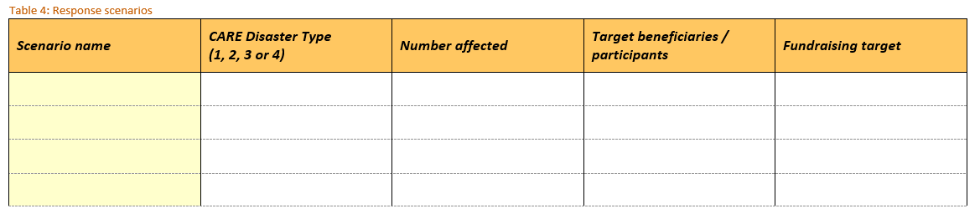
Program Matrix
The program matrix, in section 3 of the CARE EPP Workbook, aims to promote coherence across the country program as well as across CARE’s global humanitarian programming. It reflects the key program decisions that need to be taken for a CARE response. You must add the following information:
- Response sectors: As per CI protocols, CARE and its partners should respond in at least one of the four core emergency sectors (WASH, shelter, SRHR, food security). CARE and partners may also respond in other sectors where there is a critical need and in which they consider they can add value and where appropriate expertise exists (consider partners’ capacity to respond as well). Sectors should be chosen based on both the anticipated needs for the applicable hazards and the capacity of CARE (globally, not just in country), to implement programming in those sectors.
- Disaster risks applicable: Specify for which hazards/disaster risks CARE and its partners plan to intervene in the chosen sectors.
- Program interventions: List the key interventions/activities which CARE should implement for each combination of hazard and sector identified. Proposed interventions should align with CI sectoral standards and the country humanitarian strategy (where available). The program intervention is not intended to be a detailed sector-by-sector plan, but rather a short list of specific planned interventions.
- Gender considerations: Explain how the listed interventions/activities will identify and address gender issues. Refer to the Gender in Brief and, if available, any relevant recent Rapid Gender Analyses when selecting interventions. The following questions will also help in generating gender-sensitive, gender-responsive and/or -transformative interventions.
- Do the proposed interventions address the different needs and capacities/coping strategies of women and men, boys and girls?
- What are the differences in women and men’s roles and responsibilities with regard to food preparation/nutrition, water and fuel collection, the household’s hygiene, building and maintaining the shelter and any private or collective latrines, etc.?
- Are there any socio-cultural practices, taboos or beliefs that may affect women/men differently, e.g. mobility restrictions outside of the household compound, the need to be accompanied to medical facilities?
- Who within the household has control over livelihood and household resources?
- Are there differences between women and men in their access to assistance?
- Are women and men being consulted equally?
- Are there local women’s organizations or women’s leaders that can support the response? If so, has CARE made contact with the organization or leader to consider collaboration or partnership on assessments/analyses, implementation, monitoring and evaluation?
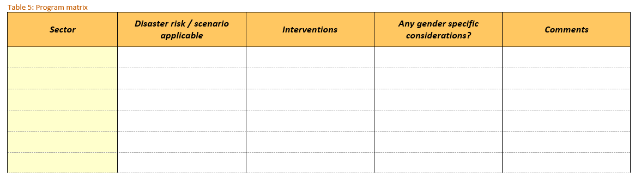
Gender Action Plan – See Annex 9c or the Gender Wiki for further detailed guidance.
Partnerships Matrix
CARE offices should identify partners for their responses in advance. Ideally those partners should be included in the emergency preparedness planning process.
The partnerships matrix records details of the key partner organizations for CARE. You should add the following information:
- Partner organizations: The names of the partner organizations
- Capacity in gender equality: Whether the partner organizations have understanding of gender issues and capacity to identify and address gender in emergencies issues.
- Proposed role: The role that partners will play in your response plans. Highlight which areas in which they have particular strengths.
- MOU: Whether there is a memorandum of understanding which sets out the relationship between CARE and the partner organization.
- Capacity assessment: Whether a capacity assessment of the partner organization has been completed. If it has, link to it, or add the capacity assessment as an annex to the workbook.
- Capacity building plans: Whether plans for capacity building of the partner by CARE, or vice versa, are in place.
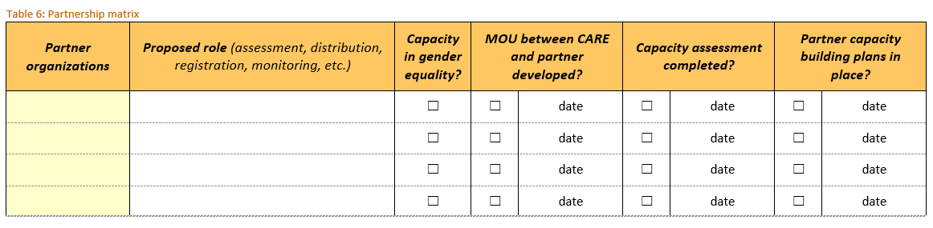
Annex 7 – minimum preparedness actions
Mandated MPAs
CARE has mandated minimum preparedness actions which CARE offices must implement and periodically review as part of their preparedness process. There is a list of mandated MPAs for CARE’s offices.
https://www.careemergencytoolkit.org/wp-content/uploads/2017/03/Annex-7-CARE-Minimum-Preparedness-Actions.xlsx
Additional MPAs (also known as Custom MPAs)
CARE offices may add additional MPAs to suit their particular preparedness requirements. Lead Members may also require some additional MPAs for their offices. CARE has a list of example additional MPAs to help support the selection of additional MPAs. This list is included as a separate tab on the CARE Minimum Preparedness Actions spreadsheet (above).
See also specific considerations for supply chain preparedness, which might inform choices of additional MPAs for procurement and supply chains:
https://www.careemergencytoolkit.org/wp-content/uploads/2017/03/Annex-7a-CARE-Considerations-for-Supply-Chain-Preparedness.pptx
Any chosen additional MPAs should be listed in Table 7: Additional MPAs in the CARE EPP Workbook

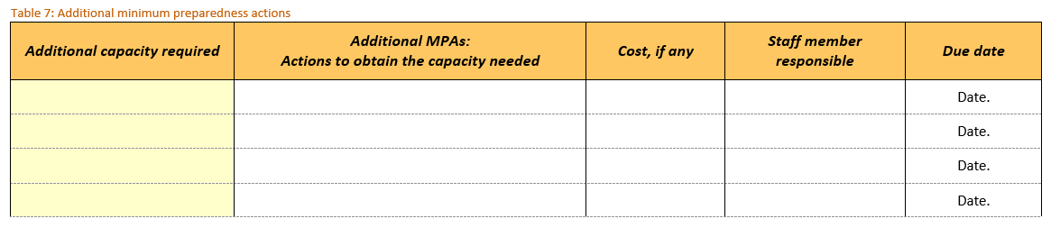
It is recommended that CARE offices carefully consider their capacity when selecting additional MPAs, and do not have too many.
Annex 8 – Advanced preparedness actions
These are the CI mandated APAs for the first 72 hours after an Alert is raised/response is started. They are also listed in the CARE Emergency Pocketbook and the CARE Emergency Toolkit. There is a suggestion for who the APA should be assigned to, so that people on the Emergency Response Team (ERT) know their roles when an emergency happens. These assignments should be made during the EPP workshop, and may be to different people than those suggestion as is appropriate for the particular CARE office. The table below can be used to make the assignments.
APA # | Advanced Preparedness Action | Completed within | Assigned to
1 | Make sure all CARE staff are safe | ASAP | ERT Lead
2 | Send an emergency alert | 24 hours | ERT Lead
3 | Call an ERT Meeting | 24 hours | ERT Lead
4 | Set up an operations room | 24 hours | ERT Lead
5 | Refer to emergency response plans and initiate any additional advanced preparedness actions | 24 hours | ERT Lead
6 | Refer to your Gender in Brief and, if available, any relevant previous Rapid Gender Analyses, and share them with CEG and the ERT | 24 hours | ERT Lead
7 | Start coordinating with:  - Affected people  - Local authorities  - The UN  - Humanitarian clusters  - Other NGOs | 24 hours
8 | Keep finding out as much as you can about the situation | 24 hours | ERT Lead
9 | Arrange a Crisis Coordination Group call | 72 hours | Country Director
10 | Activate the office’s emergency operating procedures (e.g. finance, procurement) | 72 hours | Country Director
11 | Send a gender-balanced assessment team | 72 hours | ERT Lead
12 | Ensure communications are in place | 72 hours
13 | Distribute vital supplies | 72 hours
14 | Request funds from the CI ERF if needed | 72 hours | Country Director
15 | Activate the Start Fund if appropriate | 72 hours
16 | Contact donors and submit initial concept notes for funding, along with the Gender in Brief | 72 hours
17 | Use the office capacity assessment to decide what additional resources to request from CI | 72 hours | ERT Lead
18 | Request the CI HR Coordinator for deployments of key personnel from the CI Roster | 72 hours | ERT Lead
19 | Update the organizational chart to clearly show lines of authority and responsibility for the response | 72 hours | Country Director
20 | Decide who will be the media contact and spokesperson (they might not be same person) | 72 hours | Country Director
21 | Send quotes, photos and information to CI for media releases and stories | 72 hours
22 | Suggest what messages to use for complex advocacy issues | 72 hours
23 | Refer to your scenario-based response plan and develop an initial response strategy | 72 hours | ERT Lead
24 | Write a generic proposal and share with CI, with the Gender in Brief attached | 72 hours
25 | Undertake a risk assessment for the response, including effects on your normal programs. | 72 hours
26 | Put information management systems in place and assign someone to manage information | 72 hours
27 | Send regular sitreps, as agreed on the CCG call | 72 hours

Additional APAs should be listed in Table 8: Additional APAs in the CARE EPP Workbook

CARE offices which have done scenario-based response plans should consider whether those plans require the addition of specific APAs for those plans.
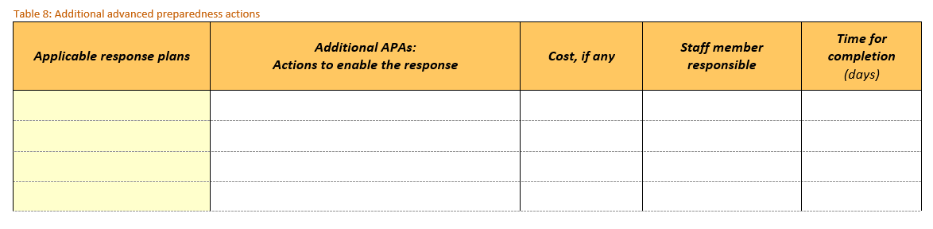
Examples of additional APAs are:
- For a cyclone response plan: Hire additional 4x4s to enable rapid mobilisation, needs assessments and response.
- For a drought response plan: Contact financial service providers and mobile operators to prepare for electronic cash grant disbursement.
Annex 9 – gender in emergencies guidance notes
9 – Gender in epp guidance note
http://gender.care2share.wikispaces.net/file/view/GIE%20Guidance%20Note-Gender%20in%20EPP.pdf/550663042/GIE%20Guidance%20Note-Gender%20in%20EPP.pdf

Annex 10 – gender in brief guidance note
http://gender.care2share.wikispaces.net/file/view/GiE%20Guidance%20Note%20Gender%20in%20Brief.pdf/602528574/GiE%20Guidance%20Note%20Gender%20in%20Brief.pdf

annex 11 – gender action plan guidance note
http://gender.care2share.wikispaces.net/file/view/GIE%20Guidance%20Note-Gender%20Action%20Plan.pdf/550663034/GIE%20Guidance%20Note-Gender%20Action%20Plan.pdf

https://interagencystandingcommittee.org/reference-group-risk-early-warning-and-preparedness/documents/iasc-emergency-response-preparedness
INFORM provides global, open-source risk assessment for humanitarian crises and disasters: http://www.inform-index.org/
http://oneresponse.info/Coordination/ClusterApproach
https://www.careemergencytoolkit.org/management/12-partnership/1-working-with-partners-in-an-emergency/1-1-care-s-strategic-commitments-for-partnering-in-emergencies/
https://www.careemergencytoolkit.org/topics-issues/32-quality-and-accountability/5-humanitarian-performance-targets/5-1-target-1-the-scale/

