

Humanitarian Protection Training Pack
Participant Workbook

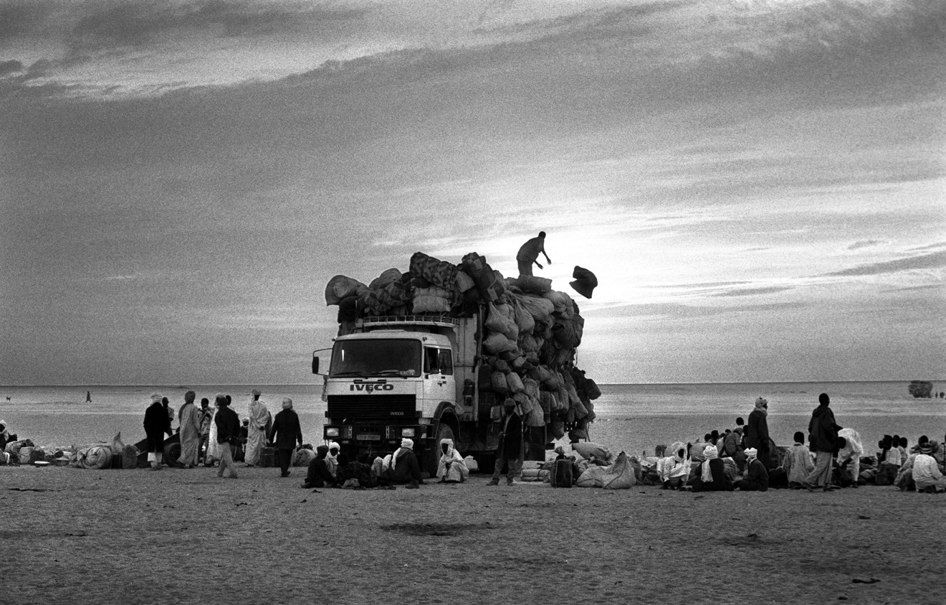

Contents

Page 3 Training Workshop Objectives

Page 4-5 Introduction Exercise: Quote cards

Page 6 Pre-training questionnaire

Page 7 Handout 1: Defining Protection

Page 8 Exercise 1: Different Categories of Protection Risk

Page 9 Handout 2: Analysing Protection Risks

Page 10 Exercise 2: Risk equation

Page 11 Handout 3: International Legal Instruments

Pages 12-19 Exercise 3: Black and White cards

Page 20 Handout 4: Roles and Responsibilities for Protection

Pages 21-22 Exercise 4: Agency Coordination

Page 23 Handout 5: Mainstreaming Protection

Page 24 Exercise 5: Mainstreaming Protection

Page 25 Exercise 6: Quiz on the ‘Minimum Agency Standards’

Pages 26-28 Exercise 7: Project Cycle Scenarios

Page 29 Exercise 8: Where are you now?

Page 30 Exercise 9: Developing a ‘Mainstreaming Action Plan’ (MAP)

Page 31 Post-training questionnaire

Page 32 Feedback Form

Training Workshop Objectives

- To understand protection and related concepts

- To understand how to mainstream protection into sector programmes

- To be familiar with the Minimum Agency Standards on Incorporating Protection into Humanitarian Action

- To be able to develop Mainstreaming Action Plans using the Minimum Agency Standards
Introduction Exercise: Quote cards
If you want to make peace, you don’t speak to your friends. You talk to your enemies.  Mother Teresa | Peace is a daily, a weekly, a monthly process, gradually changing opinions, slowly eroding old barriers, quietly building new structures.  John.F.Kennedy
The only thing it takes for evil to triumph, is for good men to do nothing.  Edmund Burke | The time is always right to do what is right.  Martin Luther King Jnr
The future belongs to those who believe in their dreams  Eleanor Roosevelt | There can be no keener revelation of a society’s soul than the way in which is treats its children  Nelson Mandela
The future depends on what we do in the present  Mahatma Gandhi | Be the change you want to see in the world  Mahatma Gandhi

The true measure of a man is how he treats someone who can do him absolutely no good.  Ann Landers | Injustice anywhere is a threat to justice everywhere.  Martin Luther King
Peace cannot exist without equality.  Edward Said | However long the night, the dawn will break.  African proverb
We don’t need food we need safety.  Iraqi girl in Safwan | Never doubt that a small group of thoughtful, committed citizens can change the world; indeed, it’s the only thing that ever has.  Margaret Mead
First, do no harm.  Hippocrates | Peace is a of a thousand miles and it must be taken one step at a time.  Lyndon B Johnson

Pre-training questionnaire

Name:

CIRCLE THE NUMBER TO SHOW HOW MUCH YOU AGREE WITH THE STATEMENT

- I am confident that I know what protection means

NOT AT ALL 1 2 3 4 5 COMPLETELY

- I have used a protection approach in my current work

NEVER 1 2 3 4 5 ALWAYS

- ‘Doing’ protection is part of my job

NEVER 1 2 3 4 5 ALWAYS

- I will be using a protection approach in my job in the next 6 months

NEVER 1 2 3 4 5 ALWAYS

If you answered questions 2-5 please give 3 examples of actions you will take to use a protection approach in your work in the next six months

- ________________________________________________________________________
- ________________________________________________________________________
- ________________________________________________________________________

Handout 1

Protection is about improving the safety and the dignity of civilians

Improved safety and dignity can be achieved through the respect for individual rights and is reflected in the ICRC definition of protection:

‘Protection encompasses all activities aimed at obtaining full respect for the rights of the individual in accordance with the letter and spirit of the relevant bodies of law’ ICRC Workshop, 1999

There are three different Types of Protection Risk:

Violence (or fear of violence) | Coercion | Deliberate deprivation

Exercise 1: Different categories of protection risk

Circle the group that has been assigned to you:

adult men adult women children elderly people with disabilities

2 examples of violence in your context for your group:

2 examples of coercion in your context for your group:

2 examples of deprivation in your context for your group:

Handout 2: Analysing Protection Risks

One way to analyse protection risks is using the Risk Equation.

Threat + Vulnerability
RISK =_________________
Capacity

Example:

There is a risk that women walking to the well will get attacked

When a woman walks to the well, a man blocks her way and threatens her with violence.
The actions of the man are a threat.

The woman may be vulnerable because of the time of day she is travelling to the water source and its location in her village.

The woman has can increase her capacity to resist or prevent attack by encouraging women to travel to the water source in groups and by advocating to the village leaders to address the problem.

In order to reduce any protection risk it is necessary to:
- Reduce the threat and/or
- Reduce the vulnerability and/or
- Increase the capacity.

Exercise 2: Risk Equation

Name of the risk:

What is the threat? | What activities can be taken to reduce the threat?
What are the Vulnerabilities? | What activities can be taken to reduce the vulnerabilities?
What are the possible capacities? | What activities can be taken to increase the capacities?

Handout 3: International Legal Instruments applicable in Timor Leste
Legal Instrument | Date ratified by TL | Key principles contained in instrument
International Convention on the Elimination of All Forms of Racial Discrimination (1966) | 2003 | Rights protected:  - Elimination of all forms of racial discrimination (article 2)
International Covenant on Economic, Social and Cultural Rights (1966) | 2003 | Rights protected:  - To work (article 6) /enjoyment of just conditions at work (art 7)  - To form and join trade unions (article 8)  - To social security, including social insurance (article 9)  - To an adequate standard of living (article 11)  - To an education (article 13 and 14)  - To take part in a cultural life (article 15)
International Covenant on Civil and Political Rights (1966) | 2003 | Rights protected:  - Privacy (article 17) / Marriage and family (article 23)  - Minority rights for language, culture and religion (article 27)  - Participation in public affairs with genuine periodic elections by universal suffrage (article 25)  - Freedom of expression, movement, association and assembly (article 12, 18 and 21)  - The right to life, liberty and security (articles 6 and 9)
Convention on the Elimination of Discrimination Against Women (1979) | 2003 | Rights protected:  - Equal rights to nationality (article 9)  - Equal access to education (article 10)  - Equal access to employment, social security, and protection during pregnancy (article 11)  - Equal standing before the law (article 15)
Convention Against Torture and Other Cruel, Inhuman or Degrading Treatment or Punishment (1984) | 2003 | Articles 5 – 7  Torture may not be justified by any circumstance. Any person suspected of having committed any acts prohibited in the Convention is subject to the principle of universal jurisdiction. This means that any court anywhere is empowered by international law to try it and punish it, irrespective of its place of commission or the nationality of the offender or victims.
Convention on the Rights of the Child - CRC (1989) | 2003 | Rights protected:  - Non-discrimination. Every child no matter what race, creed or religion come under the protection of the Convention (article 2)  - Best interests of the child. The best interests will be a primary consideration in all legal, administrative or social policy actions concerning children (article 3)  - Participation. The opinion and views of the child should be heard and taken into account in all those situations where it is possible (article 12)

Exercise 3: Large Cards for Group A (Black)
United Nations Security Council

Other States / State bodies

The State

Non-State Armed Actors

Exercise 3: Large Cards for Group B (White)

International Committee of the Red Cross

United Nations High Commissioner for Refugees (UNHCR)

Non-Governmental Organisations

Communities, families and individuals

Exercise 3: Small Cards for Group A (Black)

Apprehending and punishing perpetrators | Legal responsibility for upholding humanitarian law, human rights law and refugee law
Commanders and members of the forces have a personal responsibility for violations of the law | Support states e.g. approving peacekeeping missions
Maintaining international peace and security | Puts pressure on its member states to uphold their legal obligations
Coercive measures e.g. peace-enforcement and sanctions | Primary responsibility for the protection of civilians on its territory
Defence of the nation | Even though not a signatory obliged to uphold international humanitarian law

Protection of civilians in the area in which they operate | Put pressure on fellow (member) states to uphold their legal obligations
Provide troops for peacekeeping or carrying out own peacekeeping operations | Provide refuge for those fleeing persecution and conflict
Maintaining the rule of law | Provision of humanitarian aid to its citizens
Provide a safe environment for people to go about their lawful business | Promote and respect human rights

Exercise 3: Small Cards for Group B (white)

Avoid threats e.g. by fleeing, hiding, not travelling etc. | Submit to threats e.g. paying illegal taxes
Confronting threats e.g. protesting, joining militias, arming themselves | Negotiating their own safety with armed actors
Solidarity – practical help and support to family and friends | Advocate on behalf of civilians
Encourage states to sign up to International Humanitarian Law | Legally mandated to promote and disseminate international humanitarian law
Mandated to coordinate action to protect refugees and resolve refugee problems worldwide | Encourages states to promote protection of human rights and the peaceful resolution of disputes

Builds the capacity of state organs (e.g. the army) to implement international humanitarian law | Endeavours to ensure the protection of and assistance to military and civilian victims of armed conflict
Maintain a presence to discourage threats to civilians | Mainstream safety considerations into sector programmes
Build the capacity of communities to protect themselves | Provide information to people about their options
Give voice to civilians | UN global lead on protection
Assists the reintegration of returning refugees in their country of origin | Major responsibility for the protection of Internally Displaced persons (IDPs)
Handout 4 Roles and Responsibilities for Protection

Traditionally protection was viewed as the responsibility only of sovereign governments and mandated agencies.

Mandated agencies = those agencies that have been assigned a specific protection role by a recognized international body or legal instrument. For example UNHCR has responsibility for the protection of refugees under the Refugee Convention. ICRC has responsibility for the protection of prisoners and non-combatants during armed conflicts under the Geneva Conventions.
NOTE: In all cases the primary responsibility and mandate for protection lies with the State

Increasingly, specialist protection agencies have taken a stronger lead role.

Specialist protection agencies = those agencies that have dedicated protection expertise in specific protection areas such as rule of law and access to justice. For example, UNICEF is a specialist protection agency for the protection of child rights. Norwegian Refugee Council (NRC) is another example.

In the last five to ten years it has been recognized that all humanitarian actors have a role to play in protection. This role is largely seen as a ‘complementary’ or ‘support’ role.

Role Play Briefing - NGO Protection Responsibilities

Your agency has been invited to attend an inter-agency meeting on protection. Each agency has been asked to present the definition of protection that is used by their agency and to explain what role their agency can play to support the country strategy to protect civilians.
Your presentation should last no more than 3 minutes and can be presented by one or two representatives of the agency.

Notes for role play:

Exercise 4 – Agency Coordination

Scenario 1 – Agency Coordination

You are a public health team delivering a cholera response in several villages and IDP camps. When you are talking to one of the communities they tell you about an illegal checkpoint that has been set up by an armed group at a crossroads 10km away. There are many cases of women being detained and sexually abused. Your organization is not working in the location where the checkpoint is and is not a specialist in prevention or response to sexual violence. Your agency is a member of the protection national working group. What should you do with this information to make sure that another agency responds?

Scenario 2 – Agency Coordination

Your agency is working to deliver non-food items in a small town. You have seen street children in the town being beaten and abused by the local business men and police. Because your agency does not work with children, you passed the information on to an acquaintance who works for a large NGO specializing in child protection. Two months later you see the same thing happening and when you speak to local people they say that nothing has been done. What should you do to follow this up?

Exercise 4 - Coordination and Referral Table

In the place where you are working, which agency could you coordinate with to respond to cases of:
Arbitrary arrest and detention:

Sexual violence:

How can you make sure that the information that you pass on does not put more people at risk?

What are the main coordination mechanisms for protection in your country context?

What could you do if there are no agencies who can respond to the problem?

Handout 5 – Mainstreaming Protection

‘Protection mainstreaming means the incorporation of protection principles and concerns into humanitarian response: safety, dignity and rights, as well as the basic needs of civilians, are central.’

There are four main components to mainstreaming protection:

Mainstreaming Protection
Promote equal access and participation

Ensure that the needs and rights of vulnerable groups are considered in programmes
Utilise robust advocacy, reporting and referral mechanisms for protection concerns

Adapt programmes to increase safety and dignity for populations

Example: Water and sanitation project
  - ensured equal access and participation by: i) locating the water points in a central part of the camps accessible to all groups, and ii) by having women, men, people with disabilities and elderly on the water and sanitation committees
  - ensured safety by providing whistles and torches for women to be able to use the water points when dark
  - ensured the needs and rights of vulnerable groups were considered by making water carriers appropriate for the elderly and children
  - set up advocacy, reporting and referral mechanisms for any protection concerns that arise in the camp
Case Study – Mainstreaming Protection

You are designing a livelihoods project that will involve training farmers in new agricultural techniques. The agricultural techniques are focused on adaptations to land use such as terracing of land, application of fertilizer and planting methods. It will involve farmers meeting at training plot of land that is on the edge of the village. The routes to reach the training venue involve passing a military check point.

Exercise 5 – Mainstreaming Protection

What would you do to:
  - Promote equal access and participation in the project?

  - Adapt the project to increase safety and dignity of populations?

  - Ensure that the rights and needs of vulnerable groups have been addressed?

  - Utilise robust advocacy, reporting and referral mechanisms for protection concerns?

Exercise 6: Quiz on the ‘Minimum Agency Standards’

- How many sets of standards are there? And what do they cover?

- What are the key legal principles that are relevant to protection in water and sanitation programmes?

- What are the key protection concerns for incorporating protection into health programmes?

- What Sphere standards should be cross referenced when incorporating protection into shelter standards?

- How many standards are there for incorporating protection into livelihoods programmes?

- What is the difference between the common standards and the sector-specific standards?

- Which common standard provides guidance on advocacy responses?

- How many of the standards across the tool relate to the rights and needs of vulnerable groups?

- Which groups are listed as being potentially more vulnerable to protection risks?

- What is the definition of an internally displaced person (IDP)?

Exercise 7: Project Cycle Scenarios

Assessment:

An outbreak of violence has resulted in 20,000 people being displaced from surrounding villages to a school field just outside the main town. The government has established the area as a temporary IDP camp and has asked agencies to assist with the distribution of food and non-food items in the camp. The people have nothing and are in need of a quick delivery of basic items and local foodstuffs. Your agency has 100,000 USD to distribute items. You are the team leading the assessment to determine the needs of the IDPs.

Response to question at assessment table:

(Re)Design:
An outbreak of violence has resulted in 20,000 people being displaced from surrounding villages to a school field just outside the main town. The government has established the area as a temporary IDP camp and has asked agencies to assist with the distribution of food and non-food items in the camp. You have carried out an assessment and decided that you will provide rice, tents and hygiene kits in separate distributions. You must submit a simple design document for approval before you can start the distributions.

Response to question at design table:

Implement:

An outbreak of violence has resulted in 20,000 people being displaced from surrounding villages to a school field just outside the main town. The government has established the area as a temporary IDP camp and has asked agencies to assist with the distribution of food and non-food items in the camp. Your agency is distributing rice, tents and hygiene kits. You are concerned about the safety of the distribution and whether the items are reaching everyone in the camp.

Response to question at implementation table:

Monitor:

An outbreak of violence has resulted in 20,000 people being displaced from surrounding villages to a school field just outside the main town. The government has established the area as a temporary IDP camp and has asked agencies to assist with the distribution of food and non-food items in the camp. Your agency is distributing rice, tents and hygiene kits. Your team is responsible for monitoring the extent to which protection has been mainstreamed in the project.

Response to question at monitoring table:

Evaluate:

An outbreak of violence has resulted in 20,000 people being displaced from surrounding villages to a school field just outside the main town. The government asked agencies to assist with the distribution of food and non-food items in the camp. Your agency is distributed rice, tents and hygiene kits. Your team have been asked to carry out an evaluation to determine the extent to which protection was mainstreamed into the project.

Response to question at evaluation table:

Exercise 8 - Where are you Now?

Alignment Table

Name of the Project (and relevant standards):

Standard | Aligned | Not aligned | Weaknesses
Standard 1

Standard 2

Standard 3

Standard 4

Standard 5

EXAMPLE Name of the Project (and relevant standards):
Well building project – Minimum Agency Standards for incorporating protection into water and sanitation programmes
Standard | Aligned | Not aligned | Weaknesses
Standard 1  Water and sanitation programmes provide disaster-affected communities with equitable access to water and sanitation facilities |  | X | Indicator A – government has not been involved  Indicator C – There were not representatives from different parts of the population monitoring inputs

Exercise 9 - Developing a Mainstreaming Action Plan

MAP Template
Indicators that are weak (highlighted in alignment table) | Activities to address weaknesses | Time frame and responsibility
EXAMPLE  Government not adequately involved | - Set up meeting with relevant government ministry and share project details with them  - Advocate for government participation in project  - Identify ways in which project can support government priorities | Project Manager  By Dec 31

Post-training questionnaire

Name:

CIRCLE THE NUMBER TO SHOW HOW MUCH YOU AGREE WITH THE STATEMENT

- I am confident that I know what protection means

NOT AT ALL 1 2 3 4 5 COMPLETELY

- I have used a protection approach in my current work

NEVER 1 2 3 4 5 ALWAYS

- ‘Doing’ protection is part of my job

NEVER 1 2 3 4 5 ALWAYS

- I will be using a protection approach in my job in the next 6 months

NEVER 1 2 3 4 5 ALWAYS

If you answered questions 2-5 please give 3 examples of actions you will take to use a protection approach in your work in the next six months

- ________________________________________________________________________
- ________________________________________________________________________
- ________________________________________________________________________

Evaluation Form

CIRCLE THE MOST APPROPRIATE ANSWER

What did you think of the training workshop overall?

POOR ADEQUATE GOOD EXCELLENT

What did you think of the materials that were used?

POOR ADEQUATE GOOD EXCELLENT

What did you think of the facilitation?

POOR ADEQUATE GOOD EXCELLENT

What recommendations would you make to improve the training in the future?

Thank you for your participation

This risk equation is adapted from the ALNAP guide

