Annex 26.10 Phone and Internet Satellite Terminals p1/3
Quick Reference

Quick comparisons of all satellite systems – coverage maps following
 | Africa- Sth Asia | Far E.Asia Pacific | Internet connect | Wireless phone | Wireless network | Cable network | Portable
Iridium Hand phone | Yes | Yes | Slow | - | - | - | Yes
Thuraya Hand phone | Yes | No | Slow | - | - | - | Yes
RBGAN Terminal | Yes | No | Yes | No | External | No | Yes
BGAN Terminal Hughes 9201 | Yes | No | Yes | Yes | Yes | Yes | Yes
BGAN Terminal  Nera 1010 | Yes | No | Yes | Yes | External | Yes | Yes
BGAN Terminal  Thrane & Thrane  Explorer 500 | Yes | No | Yes | Desktop phone | External | Yes | Yes
Nera World Communicator | Yes | Yes | Yes | Yes | External | No | Yes
VSAT | Yes | Yes | Yes | Yes | External | Yes | No

Satellite Phone Comparisons
Item | Approximate Cost US$ | Good points | Negative points
Thuraya  SO-2510  (Danimex  P/N:123-0006) | $600-$800 | Relatively cheap  Car antenna available  Office (indoor) kit available  Cheap to call other Thuraya handsets | Low battery life.  Expensive to call landline phones, mobile phones and non-Thuraya phones.
Thuraya  SG-2520  (Danimex  P/N: 123-0007) | $955 | New with colour screen. Longer battery life.  Cheap to call within Thuraya | Covers Europe/Africa & south Asia / Pacific. Expensive when calling outside Thuraya.
Thuraya  Vehicle Docking Station | $300 | Convenient for vehicle & possibly inside a building. Must specify North or South latitude. | Short cable length limits office use. Needs a 12 Volt power supply for continuous use in office.
Thuraya Office Docking station | $400 - $500 | For inside use and for remote users to have constant contact | Antenna needs to be installed outside (on roof) and the unit to be located nearby the antenna.
Thuraya Selsat 1000 | $1,000 | For indoor and vehicle use  External antenna | Expensive to call non-Thuraya phones.
Iridium 9505A | $1,400 | Kit includes car antenna  Cheap to call within Iridium | Expensive when calling outside the Iridium system
Iridium Data Kit | $300 | Allows PC –> internet connection | Slow connection speed
Mini-M  Desktop phone | $2,500 | Operational all over the globe | Bulky and requires proper antenna alignment. Being phased out
Important Notes:
Thuraya covers Europe & Africa to South Asia. No coverage for East Asia or Pacific.
Calls within the Thuraya system are approximately $0.50 - $0.70 cents per minute.
Calls within the Iridium system are approximately $0.85 -$1.50 cents per minute.
Calls to other systems (satellite phones, landlines and mobiles) can be up to $8 per minute.
Annex 5.2 (cont’) R/BGAN Portable Satellite Terminals p2/3
For Internet connections

Item | Approximate Cost US$ | Good points | Negative points
RBGAN | $500 | Cheapest internet connection.  Easy to setup an internet connection. | Can be expensive if sending large attachments. Must be setup facing the satellite.  No telephone service.  No telephone service.
BGAN  Nera 1010 | $2,500 | Can connect via standard network cable.  (1000 Terminal uses USB)  Uses special cordless phone. | Can be expensive if sending large attachments. Must be setup facing the satellite.
BGAN  Hughes 9201 | $2,500 | As above and also with wireless PC connections. Can be used in bad weather conditions.  Uses special cordless phone. | Can be expensive if sending large attachments. Must be setup facing the satellite. Cordless phone only.
BGAN Explorer 500 |  | Lightweight and easy to setup an internet connection. Connect to PC via standard network cable.  Uses standard desktop telephone. | Can be expensive if sending large attachments. Must be setup facing the satellite.
BGAN Explorer 700 | $3,900 - $4,100 | Can install an external antenna. Convenient for longer term usage.  Uses standard desktop telephone | Can be expensive if sending large attachments. Must be setup facing the satellite.
Cordless Telephone handset | $400 - $460 | Cordless phone for use with the Nera and Hughes sat-terminal | Expensive handset. Users must remember to charge the hand set.
Office telephone | $25 | For use with Thrane & Thrane Explorer 500 & 700  Cordless phone possible

R/BGAN terminals are small light and easy to operate. All units have batteries.
They must be set up with a clear view of the satellite.
R/BGAN systems do not presently have satellite coverage in far eastern Asia (Papua New Guinea) or the Pacific. Extended coverage is expected at the end of 2007.
The approximate cost of data is $7 per Megabyte.

Nera World Communicator | $5,000  $10 / minute | Can be used across the globe. Has outdoor antenna. | Expensive if not used very carefully. Must be setup facing the satellite.
Annex 5.2 (cont’) Portable Satellite System Coverage Maps p3/3

Thuraya Satellite Phone Coverage

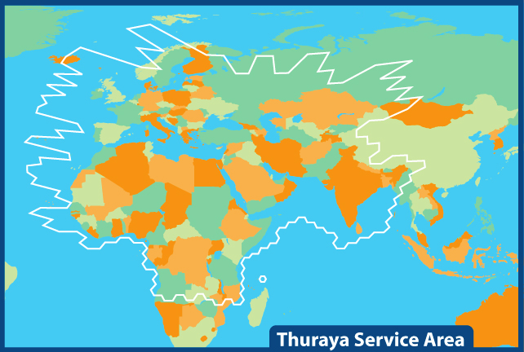

R/BGAN Satellite Phone Coverage

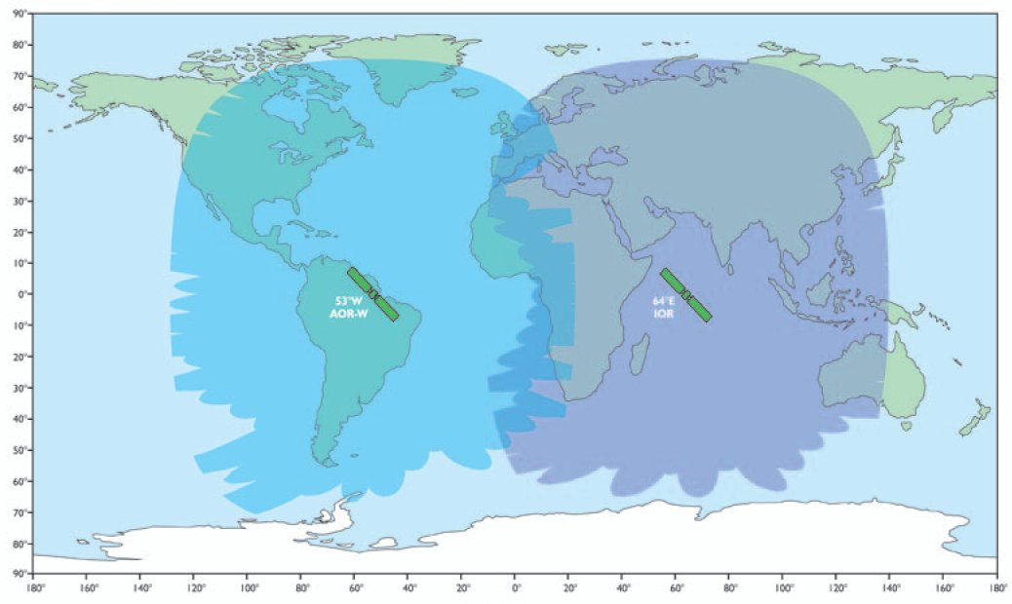
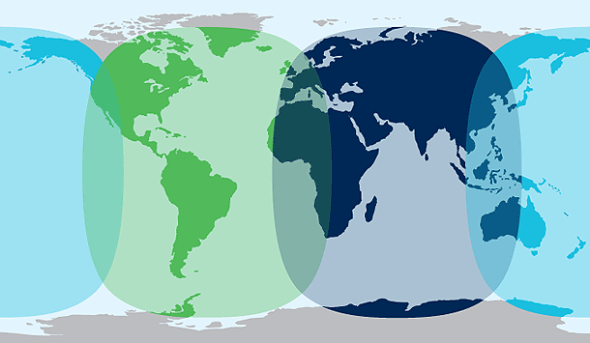

Extended coverage area expected late 2007 / early 2008

