A1.4 - Pre-registration token
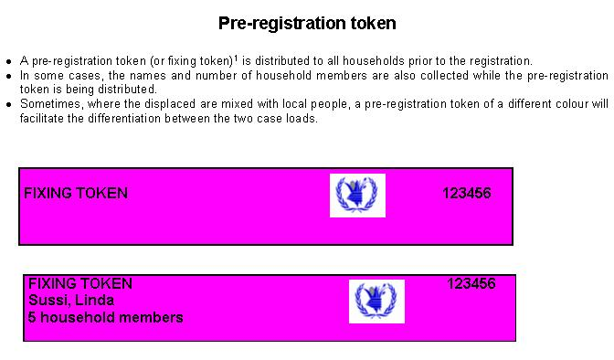

A1.5 - Registration form
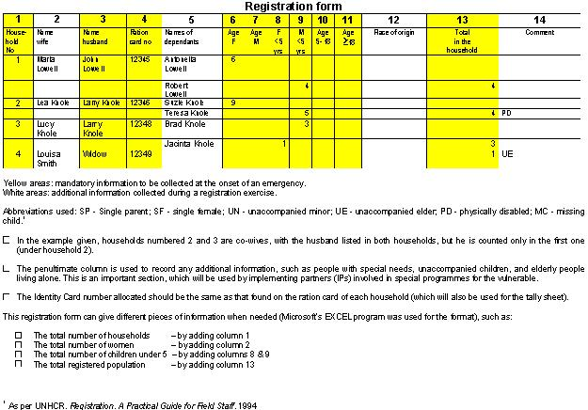

A1.6 - Ration card formats

A1.6.1 - Example 1: For camp population (displaced)
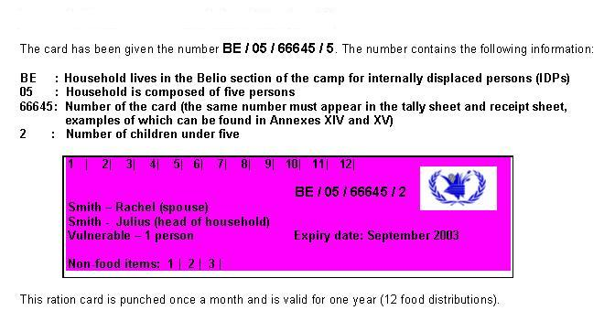

A1.6.2 - Example 2: WFP Sudan
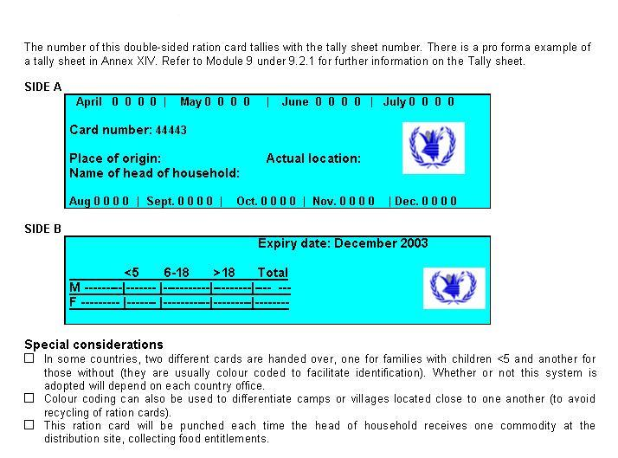

A1.6.3 - Example 3: WFP Darfur, Sudan
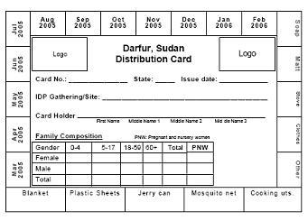

A1.6.4 - Example 4: GAA
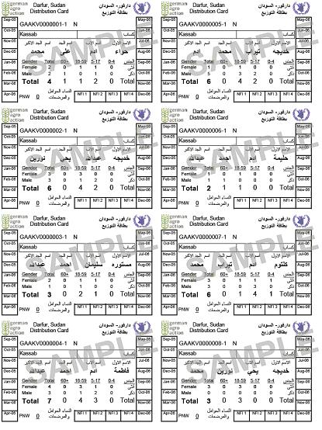

A1.6.5 - Example 5: WFP Rwanda
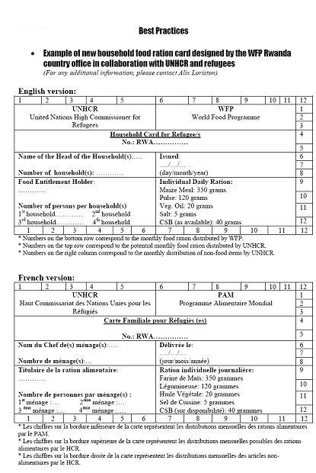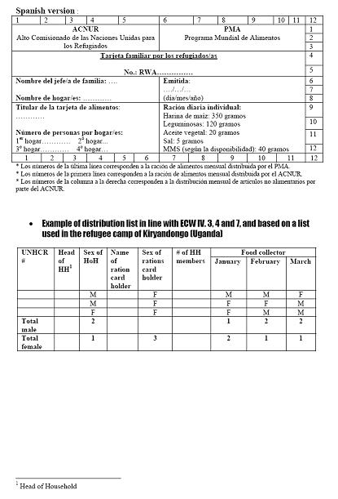

A1.6.6 - Example 6: WFP Iran
The key to the success of this ration card is that the man was indicated as the "head of household", while the woman was addressed in the card as the "food entitlement holder". This worked well in the context of the Afghan refugee camp in Iran because the men did not feel undermined by the issuance of rations cards in the women's names.
