A1.2 - Distribution Framework
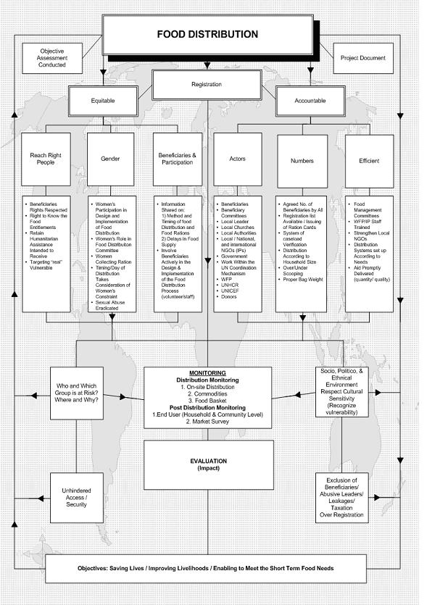

A1.3 - Registration site layout
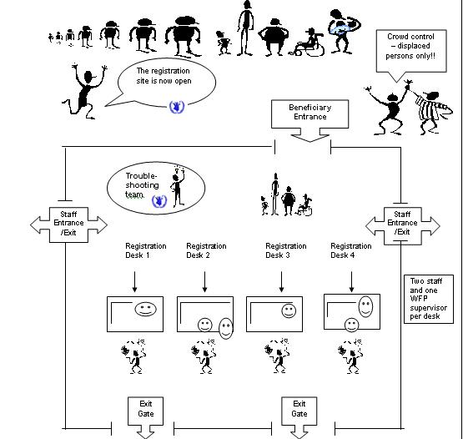

A1.4 - Pre-registration token
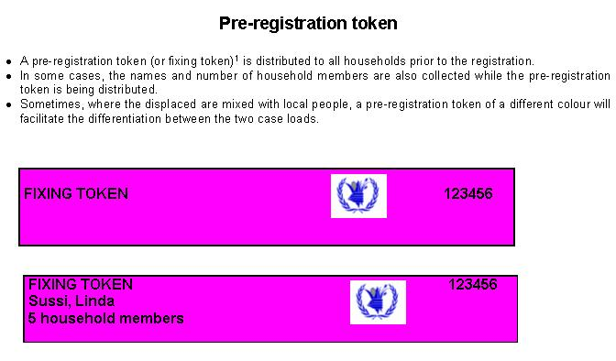

A1.5 - Registration form
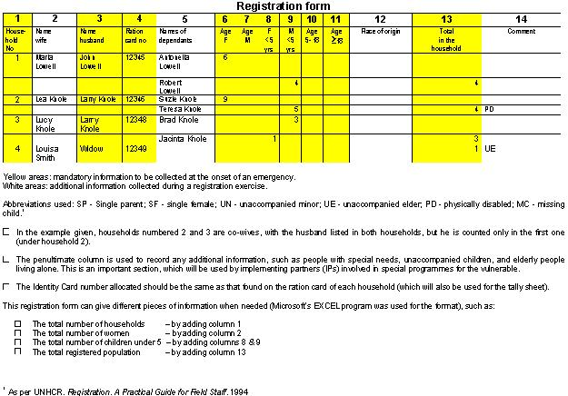

A1.6 - Ration card formats

A1.6.1 - Example 1: For camp population (displaced)
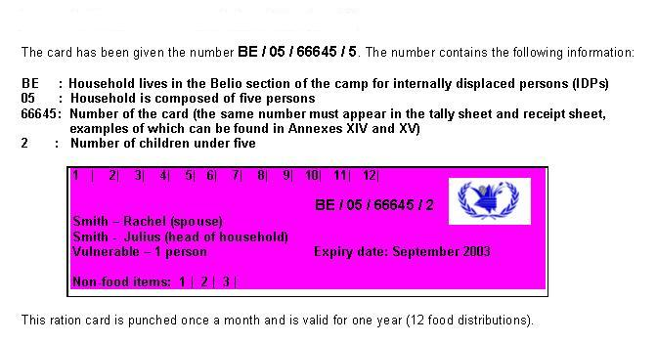

A1.6.2 - Example 2: WFP Sudan
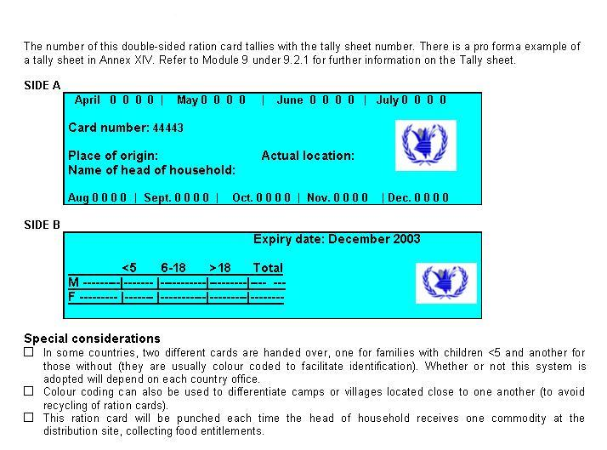

A1.6.3 - Example 3: WFP Darfur, Sudan
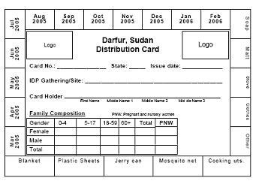

A1.6.4 - Example 4: GAA
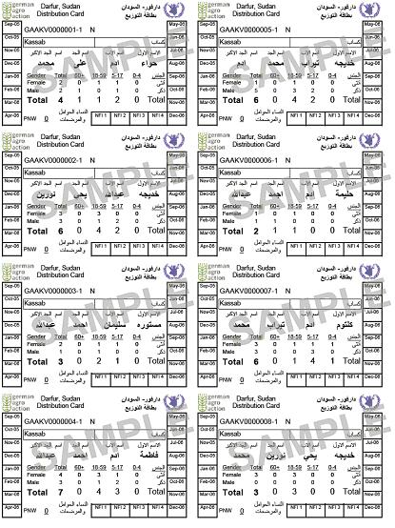

A1.6.5 - Example 5: WFP Rwanda
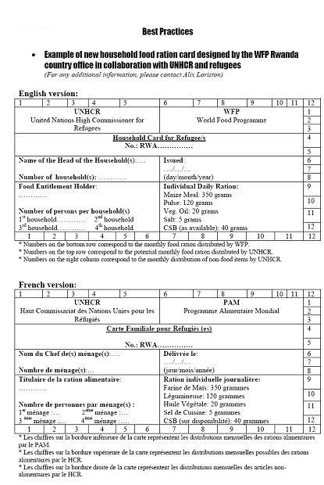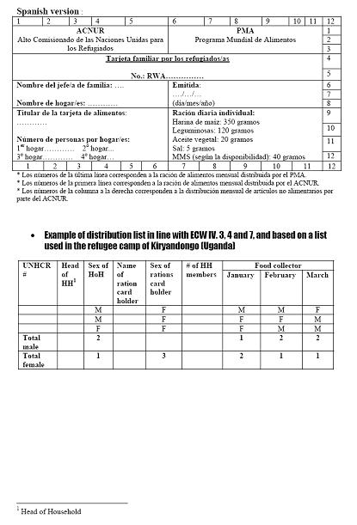

A1.6.6 - Example 6: WFP Iran
The key to the success of this ration card is that the man was indicated as the "head of household", while the woman was addressed in the card as the "food entitlement holder". This worked well in the context of the Afghan refugee camp in Iran because the men did not feel undermined by the issuance of rations cards in the women's names.
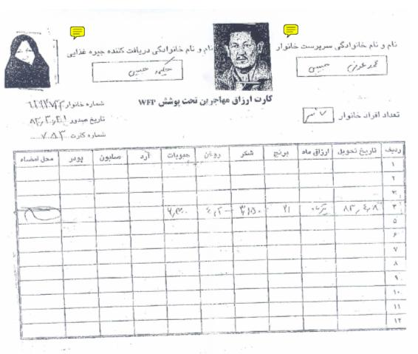

A1.15 - Receipt sheet
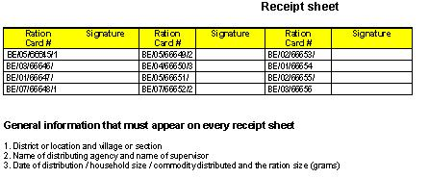
Monthly consolidated monitoring report

Guidelines
One monthly consolidated monitoring report should be provided by each of WFP’s CPs for all distributions carried out in the previous month. If WFP is carrying out a direct distribution, it is the field monitors’ responsibility to prepare such reports. Findings should be discussed with one’s immediate supervisor. The report must be sent to the WFP sub-office by a date agreed by the CP and WFP. This report should be an overview of the following reports:

  - Field Distribution monitoring report, which includes the food basket monitoring report; and
  - Post-distribution monitoring reports (end-use monitoring at household and community level and market surveys).

Location of the distribution site:
districts, and sub-office
Name of cooperating partner
Dates of monitoring
Reporting date
Total number of key informants, and  by gender | Total: Male: Female:
Report by (name of WFP field officer or implementing partner and title)

1. Number of beneficiaries

 | Planned | Actual | % (actual/planned)
Households
Female
Male
Total

2. Commodity data

2.1. Planned versus distributed amount
 | Planned (mt) | Distributed (mt) | % (Distributed/planned)
WFP commodities
Cereals
Pulses
Oil
Non-WFP commodities
Cereals
Pulses
Oil

2.2. Remaining stock
WFP commodities | Distributed (mt) | Losses (mt) | Closing balance (mt)
Cereals
Pulses
Oil
Non-WFP commodities
Cereals
Pulses
Oil

2.3. Commodity data at agency storage point
WFP | Planned | Dispatched | Received | Distributed |  | Losses (mt)
commodities | (mt) | (mt) | (mt) | (mt) | Missing | Damaged | Stolen
Maize
Pulses
Oil
Others

2.4. Explanation for losses and remaining balances

3. Distribution process and performance (efficiency)

4. Adequacy of records (registration – arrival of new beneficiaries)

5. Is there a complaints committee and are beneficiaries making use of it?

6. Use of WFP packaging materials (where applicable)
7. Women’s role in food aid management

8. Frequency of monitoring activities during the past month / 3 months / 6 months

Does your agency or WFP regularly conduct:

Distribution monitoring? Yes □ No □
Food basket monitoring? Yes □ No □
Post-distribution monitoring?* Yes □ No □
Market surveys? Yes □ No □

What are the reasons? ___________________________________________________________

9. Coordination

Describe the coordination process (e.g. how many times a month WFP/NGOs coordination meetings are organized, or how many times the food distribution committee met during the month). Give comments on the meeting process and adherance to objectives. Discuss if issues brought up are followed up etc.

10. Recommendations

List any issues that need to be discussed with WFP.

A WFP country office may decide to delete some of the headings given or add others. What is presented here is only a suggested format for a consolidated monitoring report.

