Tools developed for field visit

Clearly explain the purpose of the visit
  - CARE wants to learn from the community about the quality and accountability of our response so far, so that we can improve in the future
  - CARE wants to have better relationships, and more transparency with the community, and we would like the your opinions on how we can do this
  - CARE is carrying out a training exercise for staff, so that we can continue listening to the views of communities about our work

Depending on the situation, it is usually good to try to discuss with a group of people all together and then to do some cross checking by asking the same questions to a small number of individuals, separately. You should always make sure that you talk with women and children, not just to men and see if they have any different point of view.

Complaints PRA exercise
Clearly explain the purpose of the exercise:
  - CARE would like to set up a complaints mechanism. The reason for this is that we would like to be better at responding to your genuine complaints, questions and suggestions.
  - CARE wants to get your opinions on how to do this. We would like to understand better how you currently are interacting with CARE if you have a problem or issue, and how we can set up a system to help better respond to any complaint you may have.

Begin the exercise:
- Start conversation using project activities. What has been their experience (food, family kits, food, bamboo, seeds). If necessary explain who CARE is, what we do and how we work.
- Show the community the cards, and explain each of the symbols. You can pass them around the group. Lay the symbols on the ground so everyone can see.
- Ask people how they currently deal with issues and complaint in their village, what do they do? How do they approach CARE? What happens next? Ask what is good about this system, and what isn’t.
- If people have specific complaints, ask them to wait until the end of the discussion, and allow some time to answer their questions.
- Start with CARE’s card, and explain why we want to set up a complaints mechanism for CARE. Explain that people have the right to complain, and to receive a response to the complaint. Explain that the complaints system will only relate to the project work of CARE.
- Discuss the types of complaints that the CARE can handle: e.g. complaints that relate to the quality of CARE’s work, and how appropriate it is, whether it is reaching the most vulnerable.
- The system is not being designed for requests for new projects. CARE may not always be able to respond to requests for assistance that does not relate to projects, but may be able to share information with other agencies.
- Next identify different channels of complaint with the community, and discuss any issues that arise in relation to each channel. Discuss how these different channels are accessible to different groups in the community, women, children, disabled etc.
- Discuss the complaints form. CARE want to be able to use a simple complaints form. Discuss issues related to the form
- Discuss what will happen after a complaint is received by CARE.
  - Their complaint written on the complaint form will be analysed.
  - That a CARE staff will respond to their complaint – CARE staff will analyse and investigate the complaint, and if the complaint is valid they will review options for resolving the complaint. If no action is taken by CARE, the reasons for this will be explained to them.
- Discuss the issue of confidentiality, that only authorised people will have access to the complaint forms. That if a complaint is very sensitive then they do not have to give their name. however not giving their name can make it more difficult however to investigate a complaint.
- Discuss how information about the complaints system can be communicated to the community (notice board, CARE staff)

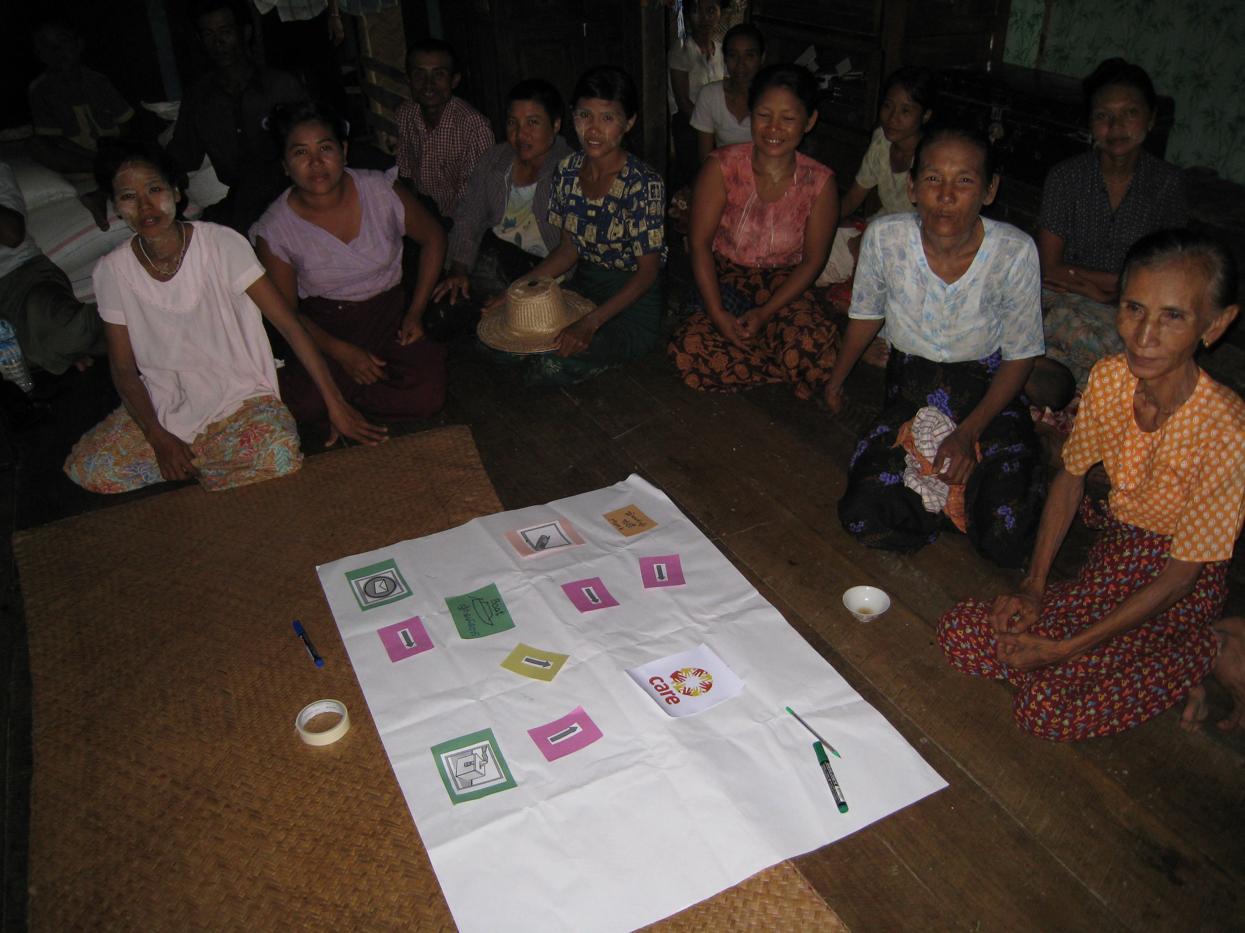
Profiling the community
Clearly explain the purpose of the exercise
  - CARE would like to ask for information about different groups in your community, especially vulnerable groups.
  - CARE want to understand if we have reached the vulnerable people with our assistance – and to ask for your opinions. Do you think that the most vulnerable have benefited from CARE’s assistance?
  - We cannot promise any assistance at this time, because this is not a needs assessment but a training exercise. However we hope that this information that we collect together can help us have a better shared understanding of your community, so that we can continue to ensure that we are helping in the best way.

District | Name of community:
Date | Name of facilitator
Individual interview ( ) | Description
Focus group ( ) | Description

- Have we (or any one else) done any assessment in your village? What was the assessment? Were you involved? When?

Total population, affected population
Injured people

Children under 5

5 – 12 year olds

Adult men (over 12)

Adult women (over 12)

Elderly (over 70)

Pregnant mothers

Lactating mothers

Disabled

People who are chronically ill

Unaccompanied children

Female headed households

Children headed households

Different social groups: ethnic, religious, or other

Different livelihood groups: land holders, fishermen, casual labourers, etc

- Are the most vulnerable benefiting from assistance? Are the specific needs of particularly vulnerable groups being considered in the assistance that has been provided?
- Who is most vulnerable amongst them? Why?
- How are these people being supported? (e.g. in distributions)
- What are the biggest risks for these people? How are these risks being addressed (by community, by agency, by other)?
- What capacities do these groups have? How are these different groups coping with the situation?
- Are any of the groups particularly difficult to access, or separated from others?

Write any notes next to groups above.

Who are the stakeholders/key informants in the village?
- Are there any community members or elders leading the people affected by the emergency?
- Other key informants? Teacher, health worker, religious leaders etc
- Any Community Based Organisations? (user groups, self help groups, youth groups, women’s group, religious church group)
- Do any of these groups have expertise, capacities?

Do you collect and maintain any information about your community?

Observations

,
Accountability monitoring tool
Clearly explain the purpose of the visit
  - CARE wants to learn from the community about the quality and accountability of our response so far, so that we can improve in the future
  - CARE wants to have better relationships, and more transparency with the community, and we would like the your opinions on how we can do this
  - CARE is carrying out a training exercise for staff, so that we can continue listening to the views of communities about our work

District | Community:
Date | Name of facilitator
Is this an individual interview ( ) or focus group ( )?
Description

Observations

Information sharing and transparency
- What do you know about CARE?
  - Who CARE is and what we do
  - What we are doing in your village (project information)
  - Do you know who CARE’s beneficiaries are and how they were selected
  - Do you know the names and roles of the staff?
  - Do you know where to find contact details for CARE?
  - Do you know of the distribution plans?

- How do you receive this information? From CARE? From committee? Is it clear? Do you think some people have more difficulties receiving or understanding this information? Why?

- If you want to know more information what do you do? Who do you ask?

- What other information do you want / need from CARE?

- How would you prefer to receive this information ? What do you feel is the best way for CARE to share information with you?

Participation
- How have you participated in CARE’s project? (e.g. identifying needs, beneficiary selection, project activities, monitoring)?

- How about the involvement of vulnerable groups?

- Were you consulted at all to clarify your priority needs and possible solutions? Or others in your village?

- Do you feel your views are represented through community structures? How were their selected as representatives of the community? Do you feel this committee was able to represent more vulnerable groups, women, elderly, children and disabled for example?

- Do you feel you have contributed to the decisions that have been made?

- What other ways would you like to be engaged in the project?

Feedback and complaint
- Has CARE asked for you feedback on the project before now?

- If you have any concerns or problems with CARE’s assistance, what do you do?

- Do you feel CARE has responded to your concerns?

- Do you have any suggestions to improve this? In the future how would you like to communicate your concerns and complaints (or suggestions) to CARE?

Targeting
- Did your family(s) receive anything from their project? If not, do you know anybody that did?

- If so, what did you receive from CARE? And when?

- How were you selected as a beneficiary? (there may be differing views)

- Did you clearly understand the selection criteria, and how people were selected? How was this communicated to you?

- Were you satisfied with this process? Do you think we reached the most vulnerable?

- Did you receive everything that you were entitled to?

- Did you have any suggestions for improvement?

Impact
- Are you satisfied with the received items you received?

- Are the items useful? How have they been used?

- Describe what difference (if any) this made to your efforts to respond to the effects of the storm?

- What would your situation be like if you had not received this assistance?

- Are there any particular vulnerable groups in your village for whom the assistance was not useful?

Overalls
- Do you have any advice or suggestions for CARE? How can we do better, in terms of quality and good and transparent relationships?

